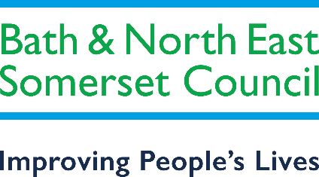

SEND Education Strategy & Action Plan

Transformation and Sufficiency

2021 - 2024

1. Introduction
This strategy sets out the next three years development of the local authority’s and the local area’s delivery of Special Educational Needs and Disability (SEND) education services, commissioning for SEND, and our SEND school place capacity. It seeks to deliver transformation and improvements in the local education sector around SEND and to build on what we do well and to ensure that we are on the road to local sufficiency and financial stability.
It continues the local authority’s on-going commitment to the SEND agenda and focuses on meeting local challenges. The challenge is to balance the delivery of support services through the Education Health and Care Plan (EHCP) process with ensuring that there are enough educational placements to meet demand. Children and young people with SEND are vulnerable in many ways for example, their vulnerability can sometimes lead to exploitation and involvement in crime and serious violence. This strategy supports the council’s commitment to improving outcomes for these children and young people through prevention work.
This SEND education strategy supports the delivery of key aims outlined in the Local Area’s overarching SEND Strategy and its improvement plan, the local Children and Young Peoples Plan. The Bath and North East Somerset (B&NES) SEND Strategy outlines the findings from the Local Area inspection in March 2019. This inspection is part of the OFSTED/Care Quality Commission review of how local areas meet their responsibilities to children and young people with Special Educational Needs and Disabilities. This inspection found a substantial number of strengths with areas for improvement. Details of these are in the SEND Strategy Report. The Strategy document can be accessed through the link below:
Bath and North East Somerset Special Educational Needs and Disability (SEND) Strategy
Children and young people have a right to be involved in all decisions that affect their lives (Article 12, United Nations Convention on the Rights of the Child). In B&NES we have been signed up to the charter since 2002.
In Bath and North East Somerset we are committed to children and young people making a real difference to how services work for them now and in the future. Listening to ‘The Voice of the Child’ underpins all our work in Children’s Services and in addition children and young people are involved in consultations, recruitment and commissioning of new services.
The strategy takes into account the changes in local area in relation to the population, the requirement to deliver services across a 0-25 age range and the link with health and social care. The strategy and its actions also take into account the cultural changes in the local educational landscape and the financial challenges faced by the local authority and local area settings, schools and colleges.
In particular, the strategy must ensure local delivery of services and educational placements within B&NES, and that inclusion in mainstream schools is better supported. Developing appropriate local education placements supported by services is key to the local area, future financial health and to enabling young people to access their local communities.

2. Our Local Area - how we know what we need to do differently?

It is essential to focus on local knowledge, and importantly our local SEND population and their needs and in particular our educational placement capacity, to deliver an effective strategy. This research is presented in our Needs Assessment, Data and Performance Review 2019 and can be accessed through the link below:
Bath and North East Somerset Annual SEND Performance Report 2019
Our challenge is partly due to our growth in the number of children who have special educational needs and disabilities, the changing needs in our growing SEND population, and the current reliance on the Independent School Sector to support these children (See Appendix 1). The reliance on the Independent Sector is mainly but not totally due to a lack of maintained/academy special school places both within B&NES and the surrounding Local Authorities. This information supports recommendations in this strategy and in particular tells us where we need to focus our services and efforts.
We have also compared ourselves against similar other LA’s who are our statistical neighbours in relation to the growth in the number of EHCPs and relative spend.
We also know from parents and carers what we need to improve, both from feedback and direct consultation. We also have our completed SEND Strategy Improvement Plan and need to update our Self Evaluation to tell us what we need to do better, or differently. We do well in the early years in identifying and networking support for children with SEND, in later years post 16 we also have strengths, although the transition process from children’s social care to adult social care is an area for improvement. It is during the school years where we need to develop better reach and leadership to work more effectively with the sector and the networks that support children and young people with SEND.
Importantly, our local families tell us they are very satisfied with the EHCP process and our support during this. However, our Parent Support Group tell us that parents sometimes feel frustrated in ensuring that schools support those pupils with SEND that do not require an EHCP. We can do better to understand their needs and support this group of pupils. A link to our the EHCP survey with parents in 2018 is viewable below:
SEND Local Offer Feedback

In addition to the above a follow up survey was sent out to all the families and young people with an EHCP to gain insight into the support they received during the COVID lockdown period from 23rd March 2020. Also viewable from the link above.

Again importantly the local families told us that they felt supported and involved in the annual review process during this difficult period.

3. Financial Stability

Our growth in SEND (see Appendix 1) is mirrored in nearly all local authorities across the country. Our overspend in high needs funding is also mirrored in nearly all these local areas and is the number one priority for most local authorities in the South West. We are not alone in our financial challenge, and we can learn from the activities of other areas. Our challenge is to reduce our reliance on the Independent School Sector and to develop our services to support and retain children and young people with SEND to remain in their local area and to be able to access local services and schools. Within B&NES we are committed to working with our schools and college to develop new provision. To-date we have opened the following:
Primary:
- A nurture unit attached to St. Nicholas, Radstock

Secondary:
- A Social Emotional and Mental Health (SEMH) unit attached to Broadlands Academy in Keynsham
- A Moderate Learning Difficulties (MLD) unit attached to St. Mark’s Academy in Bath

College:
- Addition of a unit at Bath College for young people with complex needs
In progress is a unit for Autism Spectrum Condition (ASC) attached to Oldfield School in Bath which will open in September 2021 and the expansion of Aspire Academy Special School for SEMH and SEMH with ASC and social communication from 55 to 120 places over 2 years starting in September 2021. We are also working with local Multi Academy Trusts (MATs) and maintained schools to look at developing further resource bases /units within the B&NES wider area. The creation of more special school places is also high on the agenda and we are working with the MATs and special schools to ascertain where we can increase this provision.
Appendix 4 highlights our financial challenge; shows our growth in spending in this sector and shows the type of SEND need we mainly use this provision for. Placing our children and young people in the Independent School Sector can on average be three times more expensive than placement at a local school. While some children need this provision, it is not a sustainable pattern, and our local schools need to be supported through capital investment and services to retain these children.
Our financial challenge will not resolve itself, but neither is it unresolvable. However, it will require investment and some changes in spending and commissioning behaviour to drive change. We have to spend more in some areas and invest capital, to spend less in the future. While this remains a difficult challenge in our financial climate, the focus of this work will need to address the area’s medium and long-term financial viability. The change will not be immediate and budget overspend pressures will exist for some years.
Securing capital will be a priority, and although the Free Schools Programme is currently unclear in its future, some Department for Education (DfE) funding and local borrowing can help us achieve some of our aims. Alongside this, high needs funding should be used to strengthen and adapt our support services and develop more bespoke programmes, particularly for post-16 children and young people.
We have developed and rolled out a graduated approach tool to support universal standards for SEND in all schools. To support this we have employed two part-time experienced SEND Coordinators (SENCOs) to support schools to implement this as a whole school approach as well as coordination of improvement in teaching practice.

4. Our aims – what we will do differently and our planned outcomes

This strategy has four main aims:
- Improve capacity, reach and delivery of SEND education support services by understanding current and future local need and using the commissioning process to meet this need
- Supporting inclusion by promoting best practice in education for all children and young people with SEND age 0-25
- Deliver local education SEND placement sufficiency and reduce unsustainable costs, driven by out of county placements and travel
- To reduce the strain on the mainstream sector to meet the needs of children and young people with complex and severe needs that struggle within the mainstream arena due to the lack of generic special school places.
We will then judge ourselves by the following outcomes:
- Implementation of a graduated approach for SEND in our all our educational sectors
- Fewer children having to travel out of the county for their education
- Increased appropriate special school placements
- Increase provision within resource bases attached to mainstream schools
- Reduced placement breakdowns, and reduction in fixed term and permanent exclusions for children with SEND.

The strategy can only achieve its aims by changing what we do in 4 key areas:

- Local Authority SEND Education Services (contained within the Education Inclusion Service) continuing to build on our existing partnerships by working closely with MATs and maintained schools, including SENCO conferences and wider training such as Governor training and collaborative working
- Supporting excellence in SEND teaching and practice in education sectors. Ensuring the graduated approach is embedded in all schools in B&NES as a whole school approach
- Commissioning education & support services through the high needs budget
- Commissioning and development of local educational placements.
A narrative and an action plan supports each key area in this strategy. See the table below.

5. Our 4 Key Areas of work

Key Area 1: Local Authority SEND Education Services

- The Local Authority’s Education Inclusion Service sits at the front end of delivering the Education Health Care Planning process, ensuring timely access to resources, clear application of thresholds, and clear banding descriptors for allocating SEND resources for EHCP’s.
- Whilst progress in implementing the requirements of the SEND Code of Practice 2015 has been good, and our timeliness in delivering EHCP’s is much improved; we can, however, improve our feedback and interactions with partners and families. Key to this is efficient business processes and making the best use of technology to engage and interact with children young people and stakeholders
- The service ensures that children and young people have access to suitable educational placements and support services to sustain placements. Our future priorities must focus on delivering on-going preventative support and support where placements are at risk of breaking down. We will do this by offering a continuum of support, with services offering early help, building capacity in settings by supporting the graduated approach and commissioning specialist services such as the Student & Family Support Service (SAFS), Nurture Outreach Service (NOS), Alternative Provision (AP) and Specialist Autism Support Service (SASS). The Educational Psychology Service (EPS) will continue to offer support to early years settings, schools, the College and other providers for children and young people with EHCPs where there is a risk of placement breakdowns through their consultation service and the EPS advice line. We will work alongside the MATs, supporting and propagating good practice and providing challenge and support where practice falls short.
- We will continue to support early help for all children with SEND in particular with input from the Educational Psychology Service who will offer Emotional Literacy Support Assistants (ELSA) training and supervision to support the development of children and young people’s emotional literacy skills with Precision Teaching to support the development of literacy skills and with a focus on children’s independent learning skills and confidence.
- Support for early years is good, but the capacity to coordinate and support practice earlier for all children with SEND across the wider education sector is limited and needs to be improved. We need to work closely with Early Years Advisors and SEN Coordinators (SENCOs) to identify possible SEND and to deliver effective support. We will continue to offer support to early years setting SENCOs through the Area SENCO Team which sits within the EPS.
- We will also build on developing our good practice in preparing for adulthood in education through the continued development of the 0-25 agenda. We are working towards developing a Transition Strategy with adult social services to enable working together between agencies for young people moving between children and adult’s services to ensure a seamless process for all involved.
Key Area 2: Teaching and Practice in Education Sectors – supporting and developing continual sector led improvements
- The local area continues to deliver SENCO conferences, support inclusive practice and supports the SENCO Award with Bath Spa University, but the offer locally needs to be improved and better coordinated to ensure that there is a pathway of support in all settings both pre-16 and post 16 for all teachers and staff. This needs to be in partnership with key stakeholders, such as MATS, Health and Social Care colleagues. Early years SEND practice support for SEND is strong, but local authority support for SEND children without EHCP’s reduces when children enter statutory school age. We also need to achieve better local area oversight of SEND practice in all settings and can learn from other areas how this can be and implemented.
- The Local Authority can no longer be the direct provider to deliver continued support and professional development across teaching and practice to support SEND. It does, however, need to consider what it does next and the role of teaching schools, its areas of strength and what it can do differently to enable the sector to work together. Key to this will be the implementation of a sector-led graduated approach to SEND for all pupils
- We are now in the second phase in the project to roll out of a graduated approach across settings. The two part-time, SENCOs (one Primary and one Secondary) work in a variety of ways to embed the graduated approach. This includes offering peer to peer support, devising a self-evaluation for SENCOs around their understanding of the graduated approach and its implementation in their setting and continuing to develop and share resources, materials and evidence-based practice
- We also know that schools face on-going challenges with supporting pupils with SEMH and ASC; in particular, our primary settings need additional support and advice. We need to address the capacity to coordinate, innovate and support the local area better in the offer from the local authorities remaining education services. Going forward we will work closely together to improve the offer to schools and college and to meet the on-going challenges
- Permanent exclusions in Bath and North East Somerset have not increased over the last two years, and this includes children with SEND. We have increased our capacity in alternative provision to offer more preventative placements. However, more work needs to be done to utilise these placements in a preventative way. We will now look at the numbers of pupils that following a permanent exclusion subsequently were issued with an EHCP and recognise that this area needs to be addressed by working more closely with schools in the use of the graduated approach. Schools will be supported to use this approach to focus on their Career Path Development in relation to SEMH so that they are fully equipped to use best support these pupils. We also recognise that we need more local SEMH special school placements for some children and young people. We are developing this capacity for SEMH spaces in local provision. We have supported a mainstream school to develop a SEMH resource base and Aspire Academy a special school for SEMH is being extended to increase the intake to 84 in the year commencing September 2021 and 120 in the year commencing September 2022. The remit of Aspire is also increasing to offer provision for SEMH, SEMH with an ASC Diagnosis and/or social communication difficulties. The school will also extend the age range from a top age of 16 to 19.

Key Area 3: Commissioning Services through the High Needs Budget.

- The high needs budget commissions a range of services, which includes, Sensory Support, ASC Support, Alternative Provision, the Hospital Education Reintegration Service (HERS), SAFS, NOS and Early Years SEND Support. While local services are respected, the contracts need to be re-designed to respond to current and future need and pressures. We also have areas of imbalance and emerging need that need to be addressed more acutely through efficient commissioning.
- The Specialist Autism Support Service (SASS) was re-commissioned and the new contract awarded to Fosse Way School from September 2020. This new SASS contract has a clear mission; to ensure that children and young people are supported to maintain their educational placements and to achieve and thrive. The SASS uses the graduated approach when supporting settings, families, children and young people. They provide training, resources and information, targeted support with clear expectations around the setting’s responsibilities and highly specialist direct intervention where needed
- The SEND team will need to commission internally and externally in what is a changing market of traded and private services. We will look to develop more proactive services and approaches to support complex placements and schools with high levels of SEND pupils (see Appendix 2).
- Commissioning capacity has been increased with the appointment to the new role of Head of Education Commissioning. This will ensure oversight of the whole SEND system when commissioning priorities in this strategy in partnership with the Head of Education Inclusion. Education commissioning will be delivered in the context of the changing structure of the integrated commissioning arrangements of the local authority and the clinical commissioning group (CCG); this should provide opportunities for greater join up with health and social care commissioning and transition into adult services.

Key Area 4: Sufficiency of Local Educational SEND Placements

- The local area has a range of good or outstanding special schools. Our schools are now full each year and ensuring that there are enough placements is no longer possible. We will seek to encourage inclusion in a mainstream school where possible. Appendix 2 shows the number of EHC plans in the B&NES mainstream schools as at May 2021. However, we do have some gaps/capacity issues in our local provision that we need to address. Especially key is addressing a provision gap for pupils with ASD, SEMH and SLCN. Also, following COVID 19 the increase in those with high anxiety that are struggling to leave their homes and those with mental health difficulties. This is being addressed to some degree with the expansion of Aspire Special Academy. We will also address our limited placement provision for children with moderate to severe learning difficulties where inclusion is not appropriate in mainstream. This is being addressed to some degree with the opening of the unit at St. Mark’s School.
- Increasing special school places is important. However, we must seek to find opportunities to promote inclusion in mainstream schools and we will look to direct capital towards those schools that have resource bases, wish to expand existing resource bases and to support schools wishing to develop resource bases as part of their school offer.
- Our good post 16 offer also needs to be improved; we will deliver additional specialist local placement provision at this age to focus on life skills, independence, training, and employability. Equally important is the development of post 16 provision for children in specific circumstances, such as in the Youth Justice System, Looked After Children (LAC) or high risk of Not being in Education, Employment or Training (NEET). We need a different more bespoke post 16 offer for these young people, which for some will need to start earlier in key stage 4. Within the last year we have developed, in conjunction with Bath College and Youth Connect, a Learning for Work programme and a Realising Talent programme. SEND have also worked closely with MENCAP to offer an internship. In conjunction with West of England Combined Authority there is in progress a programme for all vulnerable adults to assist into employment or training – We Work for Everyone
- We have already addressed capacity in alternative provision through an increase in local spaces; the re-commission of these services is captured in the corresponding action plan. As we emerge out of lockdown from COVID 19, we are seeing a significant increase in referrals to our Hospital Education and Reintegration Service (HERS) for pupils who are unable to attend school due to medical needs. The process to re-commission a new HERS contract from September 2022 is underway and will provide an opportunity to analyse the rise in demand and to model the new service accordingly. We will complement our additional capacity by working closely with local colleges to develop a pre-16 offer for those children whose mainstream education placements are not suitable. However, a key challenge for the local area is to provide a permanent, fit for purpose, alternative provision building for some of our most vulnerable pupils.
- The implementation of these changes will help the local area move away from the financially unhealthy use of out of county provision and subsequent high transport costs. Locally delivered provision and services will also support the transition into adult services for some children and young people and will start pathways that are financially sustainable in later life. Key to our capital investments will also be the re-commissioning of support services to develop local pathways for specific groups of children to ensure young people are in suitable educational placements from the earliest opportunity. Local Authority will take a ‘place based’ approach to developing local pathways, by improving the understanding of services provided by various agencies to meet specific needs. The aim being to eliminate duplication and improve coordination and ultimately the outcomes for CYP.
- Our capital plans to provide additional SEND school placements are evolving continually. Latest updates can be found in our SEND Capital Briefing Document.

6. Delivery of the Strategy

This strategy is not a beginning, many of these changes and actions are already underway and delivering improvements. It is instead a joining of existing and new work streams that will define our actions over the next three years. In uncertain times our plans and aims may change or be adapted but our ambition to improve outcomes should remain consistent.
The following four action plans are designed to drive the activity to deliver the wide range of change needed to achieve our aims in our four main areas of work. The actions will be driven internally by our Education Inclusion Service and Commissioning Team but require successful partnerships and support from all our settings and services.

Action Plan Key Area 1: Local Authority SEND Education services

Action | Narrative | Timescale | Impact | Status | Responsible Officer
Improve the timeliness of EHCP plans | LA statutory timescale is to deliver EHCPs within 20 weeks. We will continue to maintain our current rate of doing this above 80% of the time. This is above the national average performance of 60%. This fell due to COVID but has now increased – but needs consistency | April 2022 | Children & young people receive access to resources in a timely way | Ongoing | Head of Education Inclusion Service/SEND Manager
0-25 SEND thresholds for EHCP’s | The Threshold guidance needs to be fully embedded in the SEND panels to ensure that there are clear and consistent decisions in relation to Needs Assessments and EHCP’s.  To ensure that all decisions in relation to issuing an EHCP are evidence based on good assessments and reports, annual training is held for advice givers based on the findings of the Quality Assurance Group.  Training is also to be provided to individual teams such as SASS, EP’s and S&LT. There is a plan to develop training videos for Social care and around PfA for all advice givers | Sept 2021 | With the Graduated Approach embedded in schools this should lead to a reduction in Needs Assessment Requests.  Where requests are made with the full information of assess, plan, do, review, the application of the legal test (may have SEN, may need an EHCP) for carrying out an assessment will be straightforward for the SEN team.  To ensure that plans are only granted to the top 3% of the population in-line with national data. The increase in the number of plans is currently above the SW and national figures and this has a knock-on effect on school places and High Needs funding.  To ensure that the SEN Team have robust advice on which to make the decisions on whether or not the criteria for an EHCP has been met. | Ongoing | Head of Education Inclusion Service /SEND Manager
Update the banding descriptors | An update of the original version of the banding descriptors is required as it has been identified that not all aspects are covered. This has been completed and is ready for launch in September 2021 | Sept 2021 | To ensure that all aspects of SEN are fully covered | Completed | SEND Manager
Work to decrease the use of transport especially on an individual basis and to encourage other more carbon efficient ways of accessing schools | Look at ways schools can work with parents to encourage walking, walking buses, cycling, lift sharing to reduce carbon emissions in-line with LA policy. Continue to work with parents in accepting Personal Transport Budgets (PTBs) and to lift share | Sept 2022 | Reduce inefficient use of vehicles, reduce carbon emissions. Improve the health of our children and young people | Ongoing | Head of Education Inclusion Service/SEND Manager/Passenger Transport Manager
Restructure SEND to deliver a more bespoke transitions process | Develop a “transitions team” in conjunction with Adult Social Care  Services involved such as Children’s and Adult Social Care, Health, the Youth Offending Service and SEND need to work together ensuring good robust decisions are made in a timely fashion to ensure that families and young people are well supported. A joint panel would be a way forward to support this | April 2022 | To ensure that the Pathways to Adulthood are fully implemented in-line with the voice of the young person. That transition into adult social care where appropriate are seamless for the young person. | Ongoing | Head of Education Inclusion Service/SEND Manager/ASC Commissioning Manager Specialist Services
Develop a clear transitions pathway for CYP with SEND moving into adult social care | A transitions working group has been set up and a draft policy created. This policy sets out how Bath & North East Somerset services, alongside Bath, Swindon and Wiltshire (BSW) Clinical Commissioning Group, will support young people to move beyond local Children’s Services. It focuses on the age range of 14 to 25, following the ‘preparing for adulthood’ age range described in the Children and Families Act 2014.  Following consultation, a final transitions policy will be created to facilitate collaboration and coordination between agencies for young people transitioning between children and adult’s services. This policy will identify clear transition pathways for young people accessing services across education, health and social care. | Sept 2021 | To ensure that processes are clear and transparent for families, transitions happen at the most appropriate time for the young person, and services are working together to ensure decisions are made in a timely manner. | Ongoing | Head of Education Inclusion Service
Improve and build on the good practices in relation to the Preparing for Adulthood agenda (PfA) | The special school SEND Practitioners will support specialist units attached to mainstream secondary schools moving forward to embed the transitions agenda and support these settings to create clear pathways to adulthood for their young people from year 9.  Training will be provided to these settings around the transition process and the local offer promoted to ensure that young people are aware of local options and are having their needs met within their local community where possible.  A Preparing for Adulthood (PA)template has been created for settings to complete as part of the Annual Review process to ensure that the pathways are reflected in all EHC plans from year 9 and above.  Training is taking place around outcomes for advice givers and settings to ensure that the pathways are embedded and reflected through outcomes within the EHC plans. | Sept 2021 | To ensure that the correct support is provided to the new resource bases that are being opened within B&NES attached to mainstream schools | Ongoing | Head of Education Inclusion Service/Head of Education Commissioning/SEND Manager/PfA Senior Inclusion Officers
SEND graduated approach for all settings and schools. | Implement, monitor & support a graduated approach for all settings to accurately describe the expectations of delivery of education & support for children with SEND | Jul 2022 | All settings & parent/carers understand the expectation of providing a graduated approach to high-quality teaching for children with SEND. There will be evidence that a graduated approach has been embedded across settings and other strategic partners such as Health | Ongoing | Head of Education Commissioning
Educational Psychology Service (EPS) | Settings will receive support from the EPS in implementing EHCPs and reduce the risk of placement breakdowns through the consultation service and EPS advice line. | July 2022 | All settings will have access to the EPS’s consultation service and advice line in order to receive timely advice and support in implementing EHCPs and reduce the risk of placement breakdown. This will be documented through outcome measures for all requests received. | Ongoing | Lead Educational Psychologist
The Area SENCO Team | Early years settings will receive support from the Area SENCO Team in enhancing their capacity to implement the SEND Code of Practice to support children with SEND. This will be through individual work with settings and the Area SENCO Team’s training offer. | July 2022 | Children with SEND are identified early so appropriate support is in place in their early years setting and through their transition into school. | Ongoing | Lead Educational Psychologist

Action Plan Key Area 2: Teaching and Practice in Education Sectors – developing and supporting continual sector led improvements
Action | Narrative | Timescale | Impact | Status | Responsible Officer
Support Schools in the implementation of the Graduated Approach | Resources and training to support the Graduated Approach have been provided, the next phase is to support schools and settings in the implementation of this as a whole school approach | July 2022 | Two part-time SENCOs have been seconded to support their SENCO colleagues in a variety of ways in order to embed the Graduated Approach. This secondment was due to end in July 2021, but due to limitations in their ability to support SENCOs during the lockdown, this will be extended into 2021-2022. | Ongoing | Head of Education Commissioning
Continue to support the development of our SENCOs | We will continue to work and identify capacity to work with the education sector to support SENCO’s and to support the Bath Spa University SENCO award | Jul 2022 | The 3 x year SENCO Conferences facilitated by the LA provides high quality CPD around topics identified as priorities by SENCOs, as well as providing an opportunity to update colleagues on local and national policy developments  Two part-time SENCOs have been seconded to support their SENCO colleagues in a variety of ways in order to embed the Graduated Approach. This secondment was due to end in July 2021, but due to limitations in their ability to support SENCOs during the lockdown, this will be extended into 2021-2022. | Ongoing | Head of Education Commissioning/Head of Education Inclusion Service
Supporting SENCOs from a local area perspective | Alongside the work to embed a graduated approach in our schools and settings, we will establish a support mechanism for SENCOs who are new to B&NES and/or new to the role. E.g. 6 peer-to-peer sessions with an experienced colleague and with a particular focus on B&NES | July 2022 | In addition to the National SENCO Award and the B&NES SENCO conferences, we recognise the need to offer support to SENCOs new to B&NES, and/or the role, around local procedures, resources and services. | Ongoing | Head of Education Commissioning/Head of Education Inclusion Service
Supporting the work of our local teaching schools & college | We will work with our local teaching schools & college to support and develop training and innovation and so drive sector improvements. This was put on hold in 2020/2021 due to COVID. There is a newly established Teaching School Hub that will continue to provide support and development, particularly for Early Career Teachers and National Qualifications. Our regional Whole School SEND Representative will also contribute to this, | July 2022 | The teaching schools, college and whole school SEND colleague work with will consider and deliver an offer to promote improvements in SEND Teaching and Practice | Ongoing | Head of Education Commissioning
Improving attainment and progress for children with SEND in our Schools | We will work with our local school improvement strategy to drive improvements in attainment and performance for all children with SEND. To-date 7 primary schools with high levels of SEND have been identified to work with the Primary Empowerment Project. A post will be funded by St. John’s Foundation that will enable there to be focus on all aspects that impact on the attainment and progress of identified pupils.  Schools Standards Board to work with the Education Endowment Foundation as a pilot project to calculate the average attainment for disadvantaged pupils in reading, writing and mathematics Expected + at the end of KS2 and Attainment 8 at the end of KS4. Although this is not specifically for young people with SEND it will include this cohort | Jul 2022 | Children with SEND will have year on year improvements in their attainment and performance at school | Ongoing | Head of Education Commissioning/Head of Education Inclusion Service
Closing the ‘word gap’ in the Foundation Stage | Our Early Years Advisory Teachers and Speech and Language Therapists from Virgin Care have teamed up with the St John’s Foundation to launch a project, ‘Language for Life’, in 7 Primary Schools and their local EY providers (nurseries and child minders) | Nov 2023 | A child’s vocabulary level at the end of Reception is a key indicator of future academic success, up to 50% of the most vulnerable children start school with significantly delayed vocabulary. In ‘Language for Life’, the targeted schools and EY providers will be provided with the ‘Wellcom’ language programme resources and training in how to use it. The impact of the early identification and intervention ‘Wellcom’ provides will be evaluated in partnership with Bath University. | Project commenced May 2021 | Early Years Advisor and Professional Lead for Children’s Speech and Language Therapy
Preparing for Adulthood Agenda | Training opportunities will be provided to mainstream settings around the preparing for adulthood agenda.  Specialist preparing for adulthood practitioners will work with specialist units attached to mainstream schools to ensure that the pathways are planned and implemented for these young people from year 9.  A new Preparing for Adulthood template will be introduced to schools to complete as part of the annual review process for young people year 9 and above to ensure that EHC plans can be updated to encompass the pathways and are current and relevant to young people moving into adulthood. | By the end of the Academic year 2021/2022 | All mainstream settings and specialist units will have a good understanding of the preparing for adulthood agenda and will be able to incorporate this into all annual reviews from year 9 and above.  All EHC plans across BANES will incorporate the Preparing for Adulthood pathways and this will be reflected in outcomes and provision for young people | Ongoing | Head of Education Inclusion/SEND Manager
Tackling rising exclusions | Exclusions for children with SEND and all children have increased. We will work with our Schools Standards Board to address this issue and find ways to work more preventatively. Alongside this, we will develop a targeted service for children with EHCP’s and issue SEND exclusions guidance for all schools | Jul 2022 | Schools will have clear guidance on exclusion processes for EHCP children and have access to additional support to prevent exclusion  Guidance completed more work starting with ALT & CMES | Ongoing | Head of Education Inclusion Service/Children Missing education Manager/Alternative Learning Team Manager/Education Inclusion Coordinator (temporary post)

Action Plan Key Area 3: Commissioning Services through the High Needs Budget.
Action | Narrative | Timescale | Impact | Status | Responsible Officer
Commissioning & contract capacity | We will create additional capacity within our preventative services commissioning team to deliver commissioning intentions and support our aims | Sept 2021 | SEND commissioned services will be re-commissioned and services will have more oversight and strategic direction | Ongoing | Head of Education Commissioning
0-25 SEND Team commissioning | We will look to work closely with other agencies to support schools to identify SEND and to work with pupils at SEN support to prevent placement breakdowns.  In addition we will work to ensure that information is shared across health, education and social care (in the form of a dynamic register) about CYP who are at risk of an escalation in their mental health so that support can be put in place quickly, including support to help prevent placement breakdowns. | Jul 2022 | The LA will be able to react better to schools needing additional support to prevent placement breakdown | Ongoing | Head of Education Commissioning/Head of Education Inclusion Service
Specialist Autism Support Service - SASS | The focus will now be on working together to improve the outcomes for children and young people up to the age of 25 with ASC | Jul 2022 | Children with complex ASC will be supported to sustain school placements and schools will develop autism strategies & autism champions.  The recommissioned service will deliver the support in line with the new contract and in conjunction with the LA | Ongoing | Head of Education Commissioning
Sensory Support Service | We will work with the SSS to improve outcomes for Visually Impaired (VI), Hearing Impaired (HI) and Multi-Sensory Impaired (MSI). We will work with Weston All Saints Primary School HI Base to ensure that the needs of the children are met and that the recruitment for a Qualified Teacher of the Deaf (QTD) is pursued to fulfill contractual obligations. | End of the academic year 2021/22 | The SSS will work with the full age range 0-25 and provide an ongoing high caliber of support to B&NES Children and Young People (CYP) | Ongoing | Head of Education Commissioning/Head of Education Inclusion Service
Early years Support | We will re-commission our Specialist Early Years Education Provision (Bath Opportunity Pre School) (BOP) and our Nurture Outreach Service (NOS) | BOP & NOS September 2022  (To request contract extension for NOS) | Children with SEND in the early years will have access to specialist nursery provision and evidence-based practice to support early years development | Ongoing | Head of Education Commissioning

Action Plan Key Area 4: Sufficiency of Local Educational SEND Placements
Action | Narrative & Progress | Timescale | Impact | Status | Responsible Officer
Expansions of SEMH provision | We will expand our provision at Aspire Special school for children with SEMH. OFSTED rated the school ‘Good’ and it is well regarded by local families | Sept 2021 – September 2022 | We will create 65 additional places in a through school from 4 to 19 for SEMH with ASC and Social communication difficulties | Ongoing | Head of Education Inclusion Service/ Head of Education Commissioning/
Post 16 Provision | We will work with Bath College and Adult Social Care (ASC) to develop residential places for children with SEND that focuses on education, life skills, and employability. | Sept 2022 | Improve the capacity within B&NES to support young people to develop life skills and work towards independence through a residential offer | Onging | Head of Education Inclusion Service
Pre 16 College options & provision children with specific needs | We will enable Bath College and Schools to work together to develop a pre-16 offer for young people who need an alternative offer including a vocational offer. | Sept 2021 | Children and young people will have access to pre-16 college provision where appropriate. More flexible courses will support our children who at risk of becoming NEET (Not in Education, Employment or Training), returning from Elective Home Education or struggling with the school environment | Ongoing | Head of Education Inclusion Service/ Head of Education Commissioning/
Supporting Mainstream Provision | We will support the development of resource bases in our mainstream schools. | Sept 2022 | We will have a broader range of resource bases to support our children with SEND in our Mainstream Schools | Ongoing | Head of Education Inclusion Service
Increasing Special School capacity | We will look to develop additional Special School Provision within B&NES, | Sept 2022 | Children with SEND will have access to local education provision and services without having to travel long distances | Ongoing | Head of Education Inclusion Service
Alternative Provision | We will re-contract our HERS service for children medically unfit for school. | Sept 2022 | Good or outstanding providers will register & deliver AP services, and we will deliver improvements in outcomes and re-integration  Primary & Secondary AP contracts are now with Learn@MAT.  The process to re-commission the HERS contract is underway so that a new provider should be in place to deliver a re-designed service specification in September 2022 | Ongoing | Head of Education Commissioning
Alternative Provision | We are committed to establishing an all-through alternative provision for our vulnerable children who have been permanently excluded or need specialist support for SEMH. | Sept 2023 | We deliver our Alternative Provision from a high-quality educational site that values some of the most vulnerable pupils in B&NES. | Ongoing | Head of Education Commissioning

Appendix 1
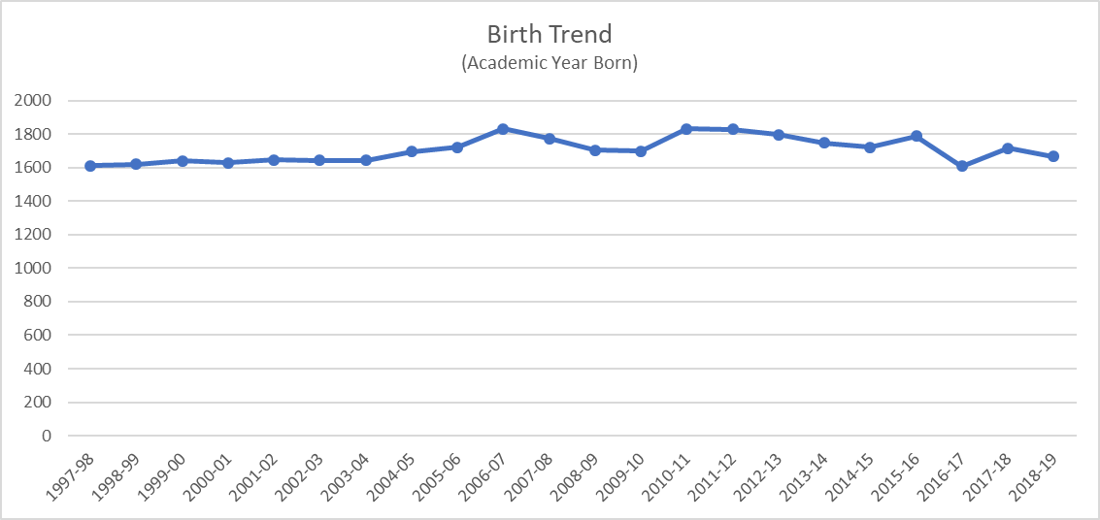
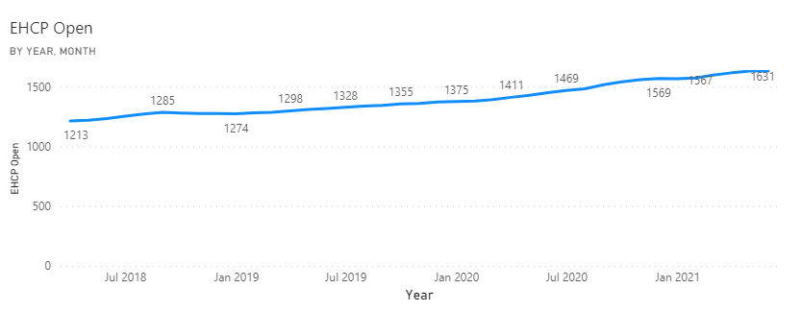

Appendix 2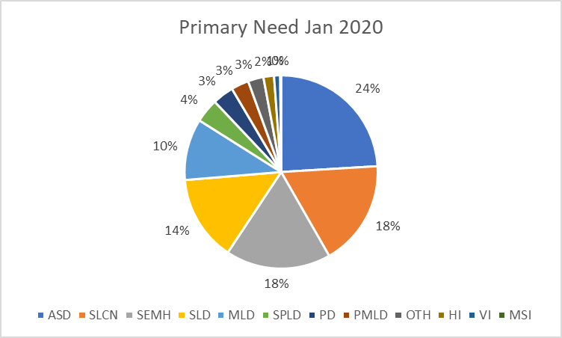
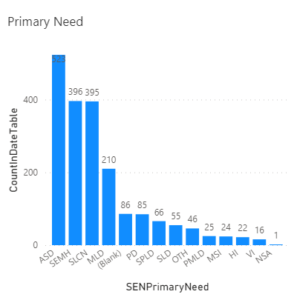
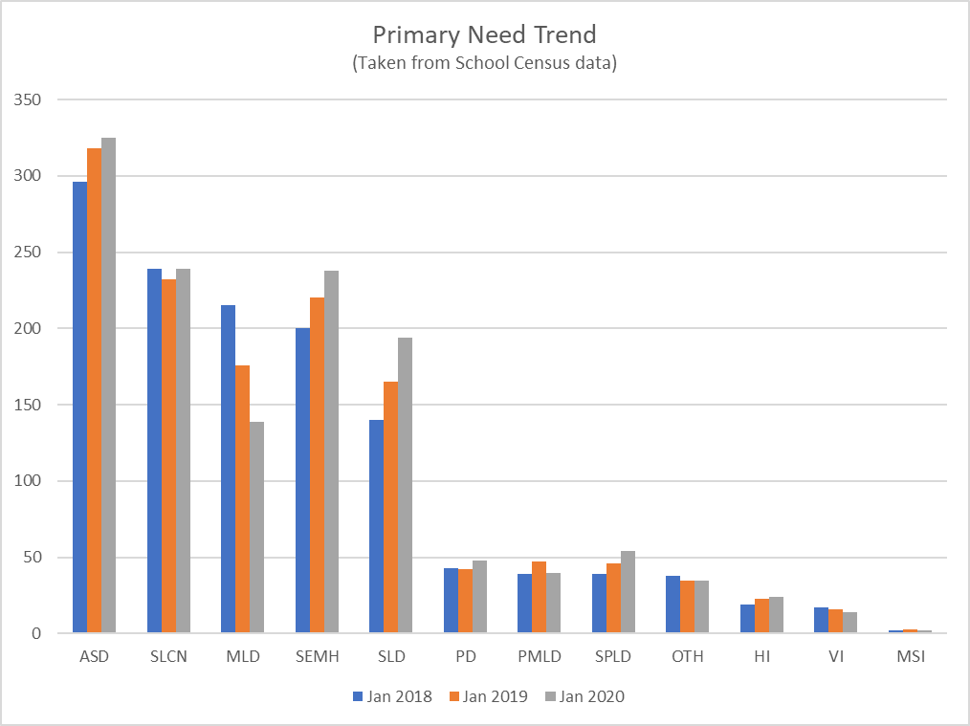

Data as of 03/06/21,
Filtered by Date (is on or after 01/04/2018 00:00:00), Year Cohort (is not Assessment Only)

Appendix 3
NB the National average for EHCP per population is 3.7%
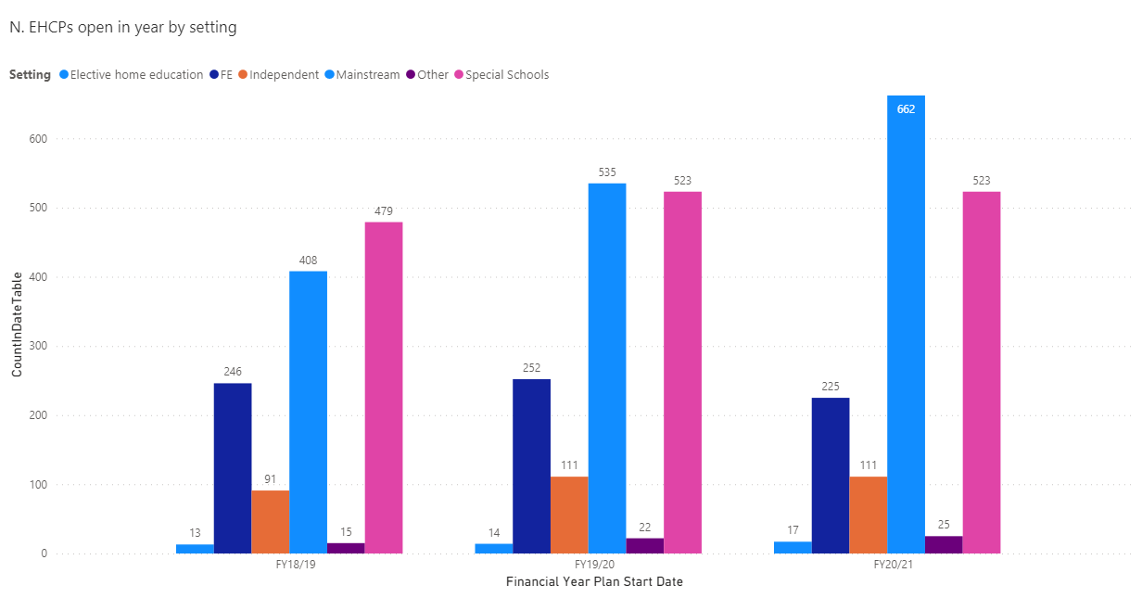

Appendix 4
