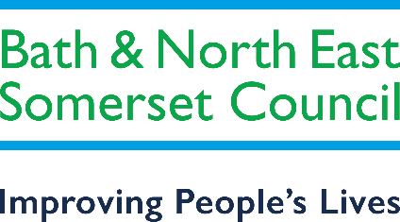

Bath and North East Somerset Special Educational Needs and Disability (SEND) Strategy
2020 - 2023

- Vision
- B&NES and SEND – an overview
- Our achievements, strengths and areas for improvement
- Achievements
- Strengths
- Areas for improvement
- Bath and North East Somerset’s Strategic
Objectives for SEND
- How we will meet our strategic objectives
- Opportunities and Challenges
- Other key strategies
- SEND Governance Arrangements
- SEND Strategy Group
- SEND Operational Group
- Monitoring, Review and Evaluation
- Looking for further information, advice or support?
- Appendix 1 – Work plan

Our vision for the B&NES SEND strategy is underpinned by the vision
of our Children and Young People’s plan 2019 – 2021:

“All children and young people will enjoy childhood and be well prepared for adult life.” (CYPP, p4)

  - Children and young people with SEND deserve the very best opportunities to learn, develop and achieve their aspirations. They also deserve the best start in life and should expect the best from all of us who provide services that aim to improve their lives and life chances.

Children and young people with SEND are given the opportunities to achieve their ambitions and the best possible educational outcomes, including getting a job and living independently as possible.

  - We want children and young people with SEND and their families and carers to experience quality arrangements which are efficient, accessible and provide for identification and early intervention in relation to their health, education and care, including support for their families and carers as appropriate.

Our vision is underpinned by Bath and North East Somerset’s overarching values, to help improve people’s lives:

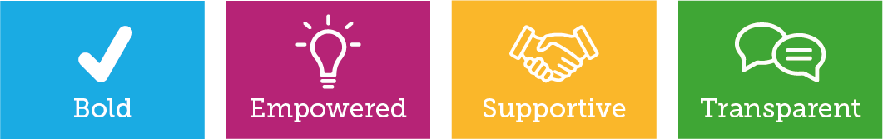

Improving People’s Lives

Greatest areas of need
  - The largest growth areas of need in B&NES are Autism Spectrum and Speech, Language and Communication (SLCN) needs
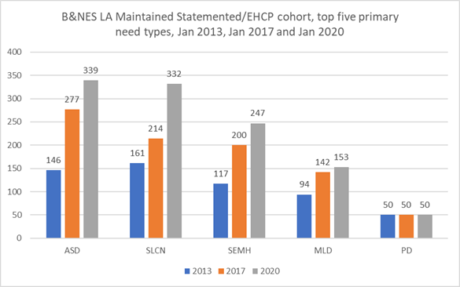

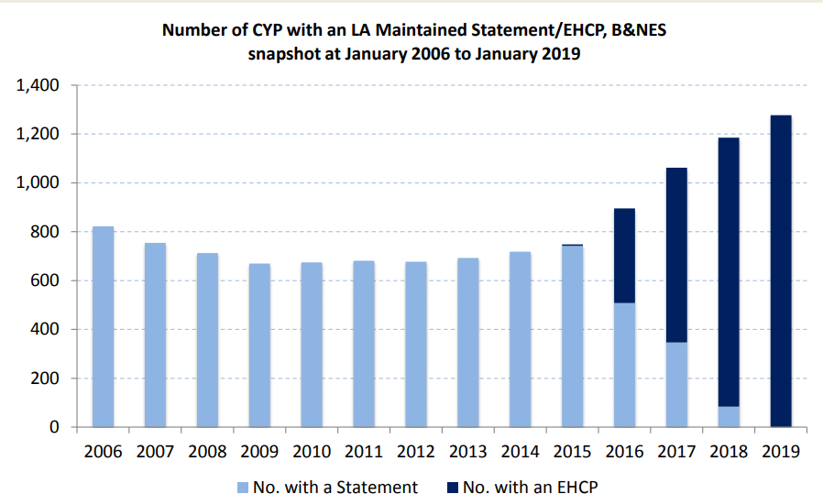
  - The number of children with statements/EHCPs has increased since 2013, but in particular since 2016.
  - B&NES have a statistically higher rate of 0-19 CYP with statements/EHCPs than nationally.
  - There has also been an increase in the number of first time EHCPs
being issued. Source: BANES Annual SEND Performance
Report, Version 5

Improvement
  - The Bath and North East Somerset Local Area was inspected in March 2019 as part of the OFSTED/Care Quality Commission inspection of local areas for Special Educational Needs and Disabilities (SEND).
  - The inspection report into the Local Area found a substantial number of strengths and some areas for improvement.
  - The revised SEND strategy 2020 – 2022 will outline and underpin how we will maintain and build upon the areas’ strengths and begin addressing areas which require improvement.
The following were identified:

Achievements

  - Positive OFSTED/CQC Local Area SEND inspection in
March 2019
  - Parent-Carers reported high levels of satisfaction with the Statutory SEND team, support from settings and feel EHCPs are helping their child to achieve outcomes – EHCP Feedback Survey August 2018
  - Early Years SEND health notification system
implemented, with helping to plan for future needs
  - Two additional SEND resource bases opened in mainstream schools and our SEMH special school has expanded by 20 places
  - Outcome data for children supported by Transition Support funding shows improving outcomes for children in the Early Years Foundation Stage (EYFS)
  - Reducing spend in placing children and young people (CYP) in the independent sector as more capacity locally means fewer CYP are being placed out of county
  - Project Search Internship Scheme successful in helping
interns finding sustainable work

- The impartial and at ‘arms-length’ SEND Partnership Service (SPS) has a very high overall user satisfaction rate and is significantly compliant with the Department for Education Minimum Standards for delivery (2018)
- 2 additional health funded clinical posts to work alongside newly commissioned LA ASD support service
- Piloting Mental Health Support Teams in targeted schools to help with pupils’ mental health issues. Linked practitioners will provide direct interventions to pupils with mild mental health support needs and offer consultation and support to staff and parents/carers.

Strengths

  - Effective strategic leadership
  - Local Leaders know the areas strengths and areas for development
  - Strong collaborative working and joint commissioning
  - Examples of effective co-production
  - Proportion of EHC plans completed within statutory 20 week timeframe is high and still improving
  - Most parent-carers feel able to access the information, advice
and support they need
  - Early identification of complex needs of babies, young children
with speech and language needs and Autism Spectrum Disorder
  - Good awareness of Electively Home Educated (EHE) cohort
  - Clear processes in place for parent-carers to participate in EHC plan development
  - Quality Assurance work is effective in identifying inconsistencies
in the quality of plans and how to improve these
- Strong planning in place for transitions
- SEND Partnership Service is well known and valued by parent carers, young people and professionals
- Leaders have reduced numbers of permanent exclusions
- Children and Young people speak positively of the support they receive
- Young people leaving Special School are well prepared for the
next stage of their education, employment or training
- Good college provision and strong local area links that enable
young people to move successfully into employment

Source: Joint OFSTED/CQC Local area SEND Inspection Report – Bath and North East Somerset

Areas for improvement identified from OFSTED/CQC Local Area SEND Inspection

- Too much variation in the way settings identify and welcome children and young people with SEND
- Diagnostic pathway for identification of older children with
Autism is less effective than the pathway for younger children
- Outcomes set in EHC plans are not always effectively followed
and monitored by settings to track progress
- The SEND Local Offer (Rainbow Resource) whilst being statutorily compliant is not seen as useful by a number of parent-carers, e.g. not clear or easy enough to find relevant information.
- Lack of clarity around accessing certain types of provision (e.g.
Short Breaks)
- Gap between academic outcomes for those pupils with SEND and other pupils in B&NES remains
- Fixed-term exclusions for children and young people remain
above the national rate in secondary and special schools.
- Annual reviews of EHC plans are not always used to check progress effectively and make necessary adjustments to provision

Source: Joint OFSTED/CQC Local area SEND Inspection Report – Bath and North East Somerset

Bath and North East Somerset’s Strategic
Objectives for SEND
Our key strategic objectives for the next two years are as follows:
- Increase sufficiency of SEND provision, including mainstream and special school, with particular focus on growth areas of Social, Emotional and Mental Health (SEMH) and Autism, taking into account the access to the curriculum that is required for these groups for example related difficulties such as learning difficulties both severe and moderate
- Improve participation and co-production with parent-carers, children, young people and young adults in commissioning of services and development of policies
- Address the gap in academic outcomes for children and young people with SEND and reduce fixed term and permanent exclusions in both secondary and special schools
- Joint working with health partners to develop a joint understanding of health pathways for CYP
with SEND, including those young people transitions into adult services.
- Provide all children, young people and their parents and carers with accurate, accessible information and communication via the SEND Local Offer and also via the impartial SEND Partnership Service.
- Improve the experience of young people who are transition beyond children’s services,
focusing on those likely to transition into adult services.

How we will meet our strategic objectives
Objective | How we will meet the objective
Increase sufficiency of SEND provision, including mainstream and special school, with particular focus on growth areas of Social, Emotional and Mental Health (SEMH) and Autism, taking into account the access to the curriculum that is required for these groups for example related difficulties such as learning difficulties both severe and moderate | A SEND Capital Plan is in place to develop provision. The SEND Education Strategy and Action plan 2018 – 2021 outlines how we will increase sufficiency of places for CYP with SEND. Consideration will be given to the type of placement made outside of the authority to inform the increase in the sufficiency within B&NES to ensure the any new provision planned will meet the variety and complexity of needs associated with the AS and SEMH cohorts
Improve consistency across the full range of settings and providers in the identification and welcoming of children and young people with SEND | A SEND Project Officer has been seconded to promote and embed a Graduated Approach throughout B&NES settings to  increase consistency in the approach to SEND.
Improve participation and co-production of parent-carers, children and young people in commissioning of services | We have consulted with and involved parent-carers in the redesign and recommissioning of services (e.g. ASD Support Service, Sensory Support Service) and will continue to do so. There is a commissioning framework for CYP. Work with health providers to ensure the voice of the child is captured more consistently
Address the gap in academic outcomes for children and young people with SEND and reduce fixed term and permanent exclusions in both secondary and special schools | We will work with our local schools standards board to continue to drive improvements in performance and attainment and work together to continue to reduce exclusions
Joint working with health partners to develop a joint understanding of health pathways for CYP with SEND | Further development of collaborative working and joint commissioning seeking greater health involvement in SEND workstreams, e.g. contribution to development of all age Autism Spectrum strategy.
Provide all children, young people and their parents and carers with accurate, accessible information and communication via the SEND Local Offer and also via the impartial SEND Partnership Service. | We are involving parent carers in the development and review of our Local Offer, including involvement in our Local Offer sub-group and developing an Autism Spectrum specific section of the website.
Improve the experience of young people who are transition beyond children’s services, focusing on those likely to transition into adult services. | - Develop a transition action plan (based on transition review) and develop joint transition policy  - Review and develop 18+ housing pathway  - Develop better modelling to predict future needs for adult services and ensure there is sufficient provision (linked to the Specialist Commissioning Service Market Place Statement).

- Opportunities
- We have an opportunity to build on joint-working processes and best practice implemented before and during the reforms in 2014
- Through recommissioning/redesigning services in co-production with parent-carers and children and young people we can deliver more tailored services
Challenges
- Pressures on High Needs Budget and general financial climate
- Increase in identification of Children and Young People (CYP)with SEND in B&NES
- Addressing the gap in academic outcomes between CYP with SEND and those pupils without

The SEND Strategy is linked to and supported by a number of other strategies:
- Interim Children and Young People’s Plan 2021-22
- Health and Wellbeing Strategy 2015 - 2019 updated strategy due shortly
- SEND Education Strategy 2021-2024
- NHS Long term Plan 2019

  - The governance arrangements for SEND are outlined in the following diagram:

Health and Wellbeing Board

SEND Strategy Group

SEND Operational Group

EHCP Quality Assurance Sub-Group

Local Offer Sub-Group
Preparing for Adulthood Sub-Group

Transitions Sub-Group
SEND Learning & Skills Partnership Sub-Group

SEND Trends Sub-Group
SEND
Partnership Service Advisory Group

The SEND Strategy Group meets Quarterly. Membership includes:

- Safeguarding and Social Care-Co-chair
- Director of Nursing & Quality- Co-chair or delegated officer
- Strategy & Policy Manager, Children’s Health & Commissioning
- Senior Commissioning Manager, Learning Disability
- Senior Commissioning Manager, Complex and Targeted
- Service Manager, Care Outcomes
- Children’s Speech & Language Lead
- Consultant Paediatrician Designated Medical Officer
- Designated Clinical Officer
- CAMHS Service Lead
- SEND Partnership Service Manager
- Senior Commissioning Manager, Early Help (Public Health)
- Parent Carer Voice Representatives
- Head Teacher, Threeways Special School

- Fosseway School Representative
- Director of Education, Inclusion and Children’s Safeguarding
- Voluntary Sector Representative
- Head of Children’s Therapies
- Service Manager-11-19 Outcomes
- Project Officer, Education Inclusion Service
- Further Education rep, Bath College
- Young People’s voices are captured and fed back to the SEND Strategy Group via young people’s groups and surveys.

- The SEND Strategy Group has a focus on three strands: SEND to be encompassed in everyone’s workstream, co-ordinated strategic commissioning of resources and to promote issues around participation.
- The SEND Strategy Group is accountable to the B&NES Community Safety and Safeguarding Partnership, B&NES Clinical Commissioning Group and the Health and Wellbeing Board.

  - The SEND Operational Group meets quarterly, the meetings take place two weeks prior to the Strategy Group.
  - The group comprises service managers and others with an operational delivery responsibility
  - The operational objectives of the SEND Operational Group are to implement the areas for improvement

- A number of ongoing sub-groups report to the SEND Operational Group. Temporary start and finish sub- groups may be established when key additional workstreams are identified e.g. SEN Early Notification sub-group.

- Current established sub-groups include:

outlined in the SEND Strategic Improvement plan by: • Preparing for Adulthood sub-group

- Identifying leads for the activities of the work streams detailed within the SEND Strategic Improvement plan
- Monitoring delivery of the work streams against the milestones detailed in the SEND Strategic improvement plan
- Preparing reports to be presented by individual work stream leads to the SEND Strategy Group when required
  - SEND Learning and Skills Partnership group
  - EHC Plan Quality Assurance sub-group
  - SEND Partnership Service Advisory group
  - SEND Local Offer sub-group
  - SEND Trends sub-group
  - Transitions sub-group

Partnership Working with Parent-Carers and Children & Young People
    - In Bath and North East Somerset we have a • Parent Carer Voice (PCV) are actively

Young People and Commissioning Framework involving young people in commissioning arrangements. Children and young people and their families and carers must be involved in planning commissioning arrangements, in the development and consideration of proposals for change and in decisions affecting the operation of commissioning arrangements.
    - Parent Carer Forum is the recognised parent carer forum in Bath and North East Somerset
involved in a number of SEND workstreams and have also provided input into the development of this strategy.
- PCV were also involved in helping us to redesign our SEND Local Offer, Rainbow Resource - https://www.rainbowresource.org.uk/ and continue to be involved in its review and development
- SEND Partnership Service – the impartial advice and support service works with local partners, including local parent and young people forums to inform and influence policy and practice in the local area

  - The B&NES SEND Strategic Improvement Plan has been produced to identify priority areas, key actions, milestones, key performance indicators and targets, including responsible services and officers.
  - The strategy will be monitored annually by the SEND Strategic Group, comprised of schools, parent representatives, health, education, post- 16, children’s and adults social care.

The evaluation of the strategy will also be informed by regular consultation and engagement with children, young people and families, inspection feedback, feedback from key processes such as annual reviews and annual SEND data collection.

  - Have increased the number of places for Children and Young People with Autism and SEMH needs to address the growing numbers of CYP with these needs in B&NES
  - Strengthen SEN Support by embedding the Graduated Approach in settings to ensure there is consistency across settings and ensuring an assess-plan- do-review cycle is followed when identifying and meeting the needs of SEN pupils
  - See an increase in the co-production of parent-carers and children, young people and disabled adults in development/commissioning of services and making our SEND local offer more useful and accessible
  - Strengthen the Annual Review process for Education, Health and Care (EHC) plans so that outcomes are effectively carried out and reviewed.
  - Improved our transitions pathways beyond children’s services, focusing on
those transitioning into adult services.

Looking for further information, advice or support?

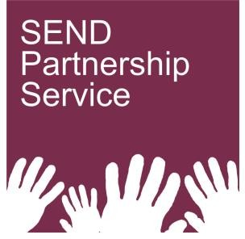
Bath and North East Somerset’s Local Offer for special educational needs and disabilities (SEND) Rainbow Resource has a wealth of information and activities, as well as the Rainbow Resource Card scheme which offers concessions and discounts for families and children and young people with SEND
- SEND Partnership Service provide impartial information, advice and support for children and young people aged 0-25 with SEND and their parent-carers– visit website follow us on Facebook

B&NES Parent Carer Forum are our parent-carer group for Bath and North East Somerset and provide support to parent-carers of children and young people with SEND
Appendix 1 – Work plan

Objective | Progress so far (as of September 2020) | Work outstanding | On track?
Increase sufficiency of SEND provision, including mainstream and special school, with particular focus on growth areas of Social, Emotional and Mental Health (SEMH) and Autism, taking into account the access to the curriculum that is required for these groups for example related difficulties such as learning difficulties both severe and moderate | Three additional SEND resource bases opened in mainstream schools and our SEMH special school has expanded by 20 places | - Proposed development of a Resource Base for 15 -20 children and young people with EHCP’s aged 11-18. In particular the provision is being considered to support children with Autism. An interim completion date has been set for this project of September 2021.  - Planning is underway to develop a new Special School, creating from 70 – 100 additional EHCP Placements for child with Autism and complex needs aged 5 – 18. An interim completion date has been set for this project of September 2021. | On track
Improve consistency across the full range of settings and providers in the identification and welcoming of children and young people with SEND | A B&NES Graduated Approach (GA) has been developed and promoted to settings. Evidence of GA being used by settings in EHC Needs Assessments | - Further work required to ensure the GA is used consistently across settings. SEND Project Officer seconded until October 2020 to complete this work. A proposal to employ two school SENCOs to assist with the implementation is awaiting approval. | On track
Improve participation and co-production of parent-carers, children and young people in commissioning of services | Parent-Carers are increasingly involved in SEND sub-groups and attend our quarterly SEND strategy group meetings | - A participation group has been recently established to work on how we can get a wider spread of parent-carers and young people involved in contributing to and co- producing the development of services. | Ongoing
Joint working with health partners to develop a joint understanding of health pathways for CYP with SEND | Annual send conference for health advice givers Participation at key strategic and operational groups  Health partners supporting the graduated approach, e.g. using assess plan do format | - Further promote graduated approach with health teams to embed as business as usual  - Health advice to be reflected in assess, plan, do, to support assessed needs | On track
Provide all children, young people and their parents and carers with accurate, accessible information and communication via the SEND Local Offer and also via the impartial SEND Partnership Service. | Local Offer sub-group re-established with Parent Carer rep. Working with parent-carer to develop Autism specific section of our SEND Local Offer | - We need to work on how we involve children and young people in the development of our Local Offer, taking into account their use of the Local Offer and what other channels might be available where CYP might prefer to access information relating to SEND. | Ongoing
Improve the experience of young people who are transition beyond children’s services, focusing on those likely to transition into adult services. | A transitions review has begun jointly between children and adult services (including health services). | - Develop a transition action plan (based on transition review) and develop joint  transition policy  - Review and develop 18+ housing pathway  - Develop better modelling to predict future needs for adult services and ensure there is sufficient provision (linked to the Specialist Commissioning Service Market Place Statement). | On track

