Inclusion in the workplace: Young Person case study

Abi, (not her real name), was enrolled onto the Learning 4 Work (L4W) course in September 2019 after withdrawing from college due to health issues. Abi has a diagnosis of autism but found it was physical health issues that held her back. Despite these challenges, thanks to the flexibility of the L4W course, she engaged well with all learning opportunities

Academic achievements made by Abi include attending Maths and English sessions with tutors from Bath College, taking an online IT course, attaining certificates in food hygiene and first aid, and achieving her Functional Skills English qualifications.

Abi has taken part in more hands-on sessions too; arts and crafts, group work projects, cooking, and virtual reality sessions. To enhance her life outside of the L4W environment, Abi has accessed Universal Credit. She applied for Personal Independence Payment, (PIP), and for her provisional driving licence, which she is regularly revising for using the DVSA Theory Test Kit application. These successes have greatly increased Abi’s independent living skills, as she wishes to live as such in the future. We also applied for a Diamond Travel Card.

Abi attended work experience sessions at a local library. She also volunteered her support for other projects; a knife crime project and was also part of some focus groups to help develop the SEND section of Live Well B&NES and the SEND Partnership Service websites.

All the above helped Abi develop life, academic and social skills, and perhaps most importantly, confidence. The Southside Youth Hub became a place where Abi felt safe and comfortable to try new skills. Moving on from L4W therefore seemed a little daunting. After looking in depth at the opportunities available to her, Abi had to decide between a supported internship at MENCAP or Project SEARCH at the Royal United Hospital (RUH). She decided on the latter. After leaving L4W, we ensured she was appointed an adult ASC Social Worker, and her Key Worker has kept in contact. Abi asked to visit Southside over Christmas and told us all about the work placements she’s experienced at the RUH; one of which was working on reception. She makes her way to Project SEARCH independently each day and is getting on excellently with the course. Options for next steps include internships, traineeships, or employment. All of which are realistic goals for Abi, thanks to the hard work and effort she put into her time on L4W.

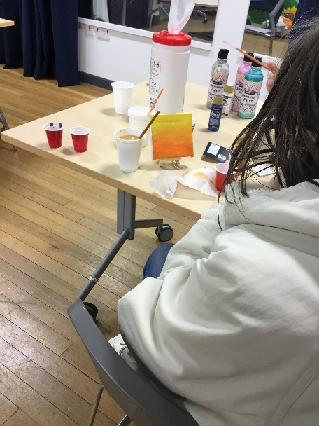
Abi taking part in an arts and crafts session at Southside Youth Hub.

