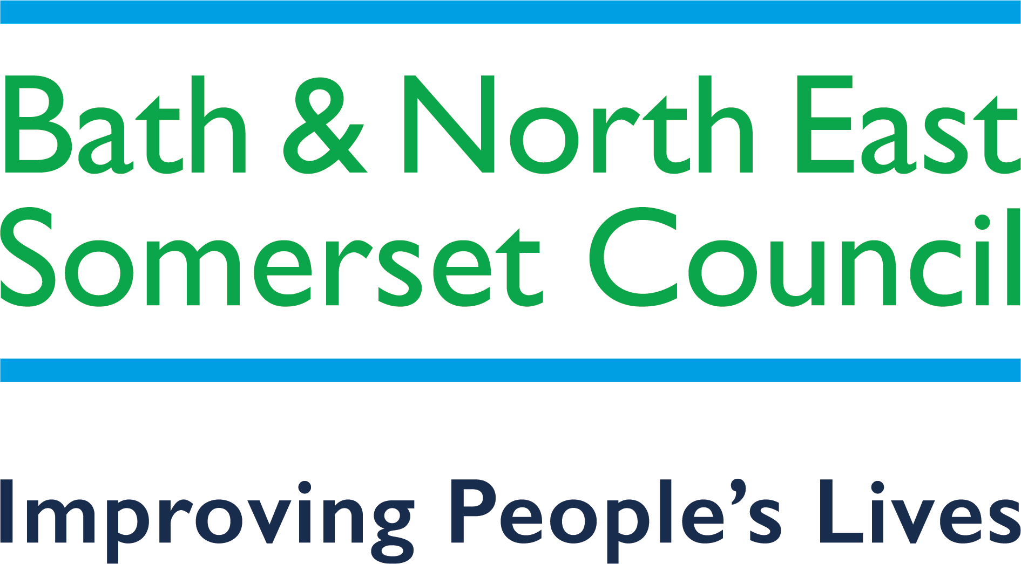
Local First Framework 2022-23
Information for Parents/Carers

Local First—what do we mean?

To achieve the Preparing for Adulthood life outcomes, we believe in enabling young people with Special Educational Needs and/or a Disability (SEND) to gain their further education locally, whenever possible. Access to good quality local educational provision is considered beneficial for many young people preparing for adulthood, as it helps them to build independence and achieve their aspirations with a network of support in their local communities.

What do families need to do?
As part of Education Health and Care planning from year 9, the following steps may be useful in investigating local provision options as a first step, with contact details overleaf:

- Approach your local College to discuss options;
- Consider a five day local Further Education bespoke package, to include respite and independent living support in ‘wrap-around’ support;
- A SEND Personal Budget can give full choice and control over tailoring support to need;
- Consider supported employment options;
- Referral to Local Authority Transitions Panel for consideration for Adult Social Services assessment.
Further information, support and advice

SENCO (Special Educational Needs Coordinator) based in all schools.
SEND Team
This team is responsible for completing the Education, Health and Care plan, organising provision and administering the plan. The SEND Practitioner for the young person can advise on local provision options. You can contact the SEND Team on 01225 394306 or by emailing special_educationalneeds@bathnes.gov.uk.
B&NES Budgets, Placements and Commissioning Officer
They can advise and signpost on local provision options, and five-day bespoke provision packages, and eligibility for SEND Personal Budgets where education funding can be linked to social care direct payments. Contact number for the B&NES Budgets, Placements and Commissioning Officer is 01225 394306.
Head of Department for Inclusion, Foundation and Alternative Provision
Please visit Bath College website to find information on a number of different courses to meet different abilities and academic levels, ranging from pre-entry through Foundation and vocational programmes to Higher Education. Courses include:
- Pathways for Adulthood (PfA) for pre-entry pupils with profound and multiple learning difficulties have complex learning needs (PMLD) learners run at Wellow House, the SEND Centre on the Somer Valley Campus at Norton Radstock Pathways for Adulthood (PfA Pre-Entry) | Bath College
- Life for Independent Living Skills (LILS) is for entry level students needing to develop life skills
- There is the potential for these courses to be built into a 5-day package or, alternatively to be delivered in partnership with Adult Social Care.
- There are also a number of work based programmes for SEND Learners including DFN Project SEARCH, Supported Routes to Employment (SuRE), Learning for Work and Traineeships. Please see Bath College website or contact the College on 01225 328560 for details.

City of Bristol College
One year’s Sensory course at pre-entry level at the Ashley Down and South Bristol Skills Academy Centres. The course is three days but this could be built into a five day package. City of Bristol College also offers a variety of Pathway and Entry Level 3 Vocational courses which enable learners with learning difficulties to progress into mainstream college, Supported Internships or help to gain independence skills.
Courses are located across four sites in Bristol, more information on each course is on the college website.
There is also the Brislington Centre which is a residential Training Facility located near the South Bristol Skills Academy (SBSA) site in Hengrove. The Transitions team would be happy to discuss entry requirements for this facility and application process. All queries need to be made through the college website using the link above.
Bristol College can be contacted by emailing learningsupport@cityofbristol.ac.uk or by visiting Bristol College’s website.

Sendias Bathnes
SENDIAS offers confidential, impartial legally based information, advice and support to children and young people with SEND aged 0-25 and their parent carers regarding education, health and social care.
They can be contacted via Sendias Bathnes website or as follows:
Call their advice line between 10.00 am – 3.00 pm Monday to Friday on 01225 394382
Email: sendias@bathnes.gov.uk

Live Well B&NES
Bath & North East Somerset’s Local Offer for children and young people with special educational needs and/or disabilities (SEND) can be found on Live Well B&NES. Here you can find local and specialist information, signposting and guidance for young people including Education, Health and Care Plans, support services and organisations, age relevant information including Preparing for Adulthood information both for young people and their parent carers amongst much more.
Visit the Live Well B&NES website to find out more.
B&NES We Work for Everyone Navigators
This Bristol-led project supports young people with disabilities into employment.
For a referral form/advice please contact Nikki Diamond via email: Nikki_dimond@bathnes.gov.uk

BANES Parent Carer Forum
The B&NES Parent Carer Forum is a voluntary group of Parent Carers of children and young people from birth to 25 years living in BANES. Through feedback and consultations with parent carers, we work in partnership with service commissioners and providers to help advocate for and raise the voice of parents and carers.

Youth Connect South West

Support young people aged 11-25 years to support, challenge and enable the learning of young people to realise their full potential. You can find out more by visiting the Youth Connect South West website or by calling 01225 396980.

Off The Record

Off The Record provide a range of free, confidential and independent services for children and young people that supports the development of their emotional health and well being. You can find out more by visiting the Off The Record website or by calling 01225 312481.

Bath and North East Somerset Community Health and Care Services (HCRG) Care Group

Provide health and social care support in B&NES, for more information please visit the HCRG website.

Preparing for Adulthood

For specific advice around preparing for adulthood you can visit the Transition Information Network. They share tools and resources to support you or your young person to prepare for adulthood please visit the NDTi website for tools and resources.

This document can be made available in a range of languages, large print, Braille, on tape, electronic and accessible formats.

