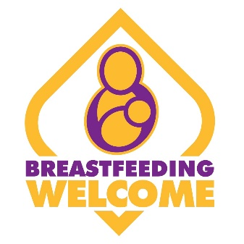
Somer Valley Breastfeeding Welcome Charter

Name of venue:
Address:
Contact name and email address:

We agree to:
- Ensure breastfeeding is welcome in all public areas and is included in written customer care policies.
- Uphold a woman’s right to breastfeed by ensuring that if someone complains, the complainant is moved, not the mother.
- If possible, provide a quiet/private area for mothers who request it.
- If applicable, inform mothers that a private place can be provided.
- Display the Breastfeeding Welcome window sticker, or certificate behind counter.
- Inform mothers that they are welcome to breastfeed.
- Offer a chair to breastfeeding or bottle-feeding mothers.
- If a venue serves food/drink, offer to bring their order to them if they are breastfeeding or bottle-feeding, or go to the mother and take her order
- Offer water to breastfeeding mothers.
- Offer a clean baby feeding area.
- Have somewhere a baby’s nappy can be changed.
- Allow space for pushchairs/prams.
- Ensure that every member of staff is aware of the scheme, the law that underpins the importance of a breastfeeding welcome space (Equality Act 2010), reads and agrees to this charter as part of their induction, and understands its importance.

This charter makes recommendations for women. For simplicity of language, the charter uses the term women/mothers throughout, but this should be taken to also include people who do not identify as women but who are breast or bottle-feeding.

I/we agree that are venue meet and will maintain the above charter principles.
Signed…………………………………………. Date……………………………………………

Please turn over.
I/we agree to be contacted by B&NES Council for matters relating to the Somer Valley Breastfeeding Welcome pilot.
Signed………………………………………….
Date……………………………………………

I/we agree to have this venue listed on promotional material about Breastfeeding Welcome spaces in the Somer Valley.
Signed………………………………………….
Date……………………………………………

For further information, please email Breastfeeding_Welcome@bathnes.gov.uk Thank you.

