

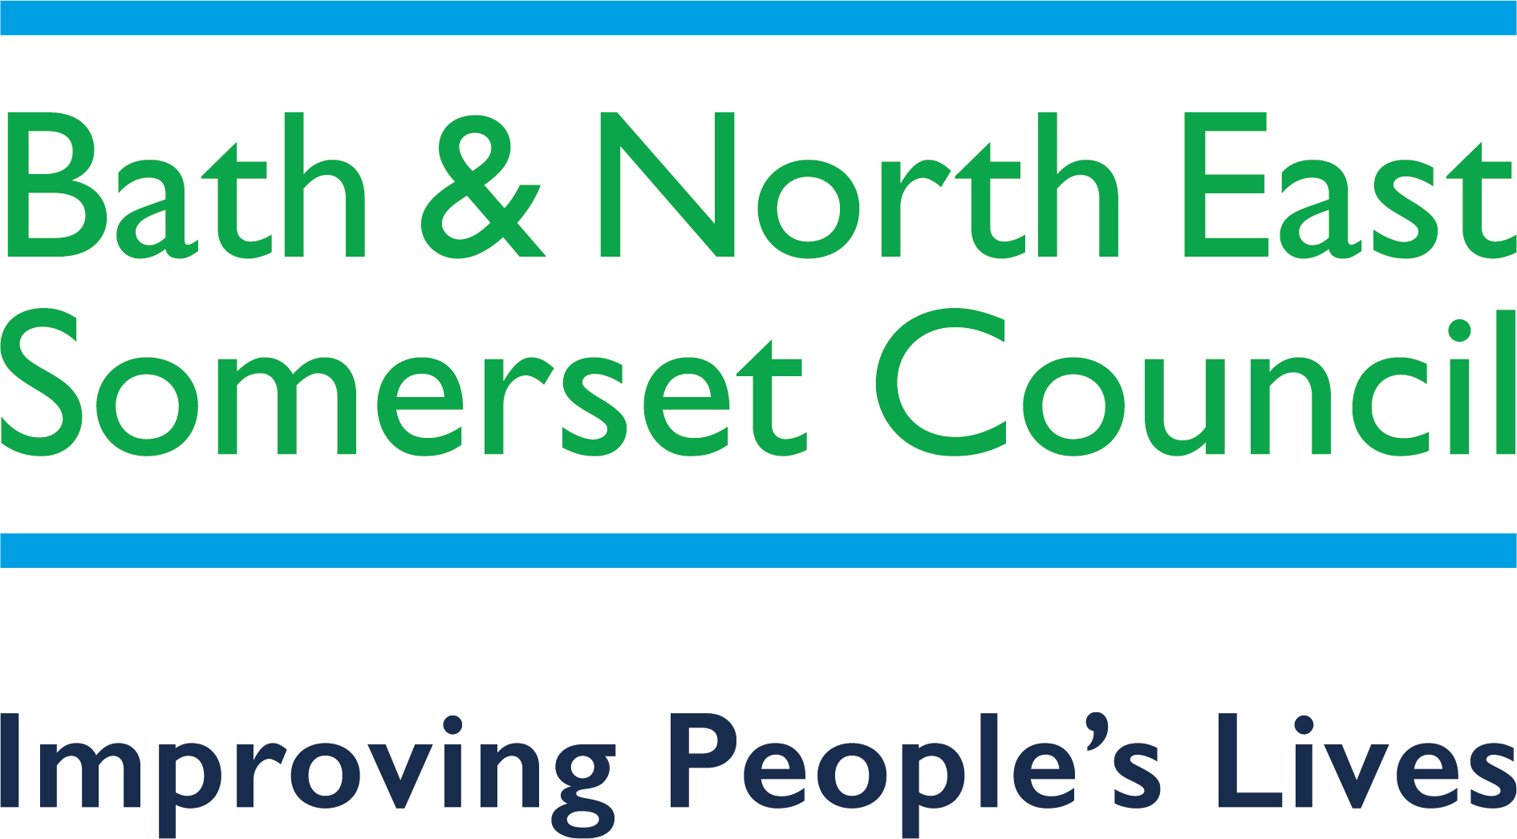

Rainbow Resource Scheme

Registration Form

This form can be completed by a parent/carer or young person. You can ask for assistance in completing the form from any professional working with your family or child/young person.
Name of Child/Young Person (One child/young person per application form)

Home address
(Please note that this Scheme is only available for families living in Bath & North East Somerset)
Postcode:

Email address:

Name of parent or carer

Child’s Date of Birth
Day | Month | Year

Child's Gender

Eligibility criteria
Please tick the relevant box(es) that apply to your child/young person’s needs:

Diagnosed condition
Has an Education, Health and/or Care Plan (EHCP)
In receipt of Disabled Living Allowance (DLA)
Receives Band C Inclusion Support Funding

Please note we may need to ask for evidence of the above.

Please provide further details below about your child/young person’s condition (for example Autism, Down’s Syndrome, long term health condition etc)

If your child/young person has a diagnosed condition please provide further details below

Diagnosed condition:

Date of diagnosis:

Name of professional:

Address:

Postcode:

Tel No:

How did you hear about The Rainbow Resource Scheme?

We are always looking to expand the scheme and are open to your suggestions for new places and attractions where your Rainbow Resource Card can be used. If you have any ideas, please share these below.

Please read and complete the declaration below

I give my consent for:

- The details that I have given on this form to be entered on to the Bath and North East Somerset Rainbow Resource database.
- The details that I have provided on this form to be included on Bath and North East Somerset’s Disabled Children’s Register in accordance with the Children’s Act 1989. If you do not wish for your child’s name to be included on Bath and North East Somerset’s Disabled Children’s Register, please email livewell@bathnes.gov.uk.
- This information to be shared anonymously for monitoring purposes only and understand that details will not be shared with any other parties, except for B&NES Carers Centre if the below box is ticked (please see below for further details).

I understand that:

- This information will be treated as confidential and if my child/young person’s circumstances or details change I am required to inform you accordingly.

Please sign below to indicate that you consent to the above declaration:

Signature:  You do not need to provide a signature if completing online form. | Date:
Please print your name:
Relationship to child:
Young person’s signature
(if appropriate)
Please print name : | Date:

Please turn over for the final page.

Additional Options

As you are completing this application, you are likely also to be eligible for a Carers Card from BANES Carers’ Centre. This is a free card that offers all registered Carers access to a variety of discounts, benefits and concessions across Bath and North East Somerset. Full details can be found on their website: www.banescarerscentre.org.uk/help-for-carers/carers-card/

As much of the essential information on their application form is the same as this one, we are able to send this information to the BANES Carers Centre securely to avoid you completing an additional application form. Please note your information will be kept securely according to both BANES Carers’ Centre and Bath and North East Somerset council’s GDPR protocol. Please see the Rainbow Resource privacy policy and BANES Carers Centre Privacy Policy for more information. You can opt out at any time by contacting livewell@bathnes.gov.uk.

Please tick this box if you agree to us securely sending your details provided within this Rainbow Resource application form across to our colleagues in Bath and North East Somerset Carers Centre in order to register you as a carer and receive your Carers Card.

We may contact Parent Carers of Rainbow Resource card holders periodically to consult with them on a variety of subjects or topics. These will likely involve requesting feedback on future proposals, potential developments to the website and future events. All feedback will be optional and you can opt out at any time by contacting livewell@bathnes.gov.uk.

If you agree to being contacted about the above, please tick the following box:

B&NES Parent Carer Forum is a group of parent carers who have children and young people aged 0-25 with SEND. They work strategically to ensure that Parent Carer voices are represented at all levels so that the services for the children and young people are appropriate for their needs. They also provide peer support, events and training opportunities for parents. By opting in, you agree to us sharing your details with the Parent Carer Forum who may contact you in relation to consultations, newsletters and peer support groups. Your details will be held securely and in accordance with GDPR regulations (please see privacy policy for full details) and you can opt out at any time by contacting livewell@bathnes.gov.uk.

If you agree to being contacted about the above, please tick the following box:

Please return this form via email (livewell@bathnes.gov.uk) or post to:

The Rainbow Resource Scheme
Livewell B&NES Team
Bath and North East Somerset Council,
Lewis House,
Manvers Street,
BATH BA1 1JG
This information can be made available in other languages and accessible formats. Please contact livewell@bathnes.gov.uk.

