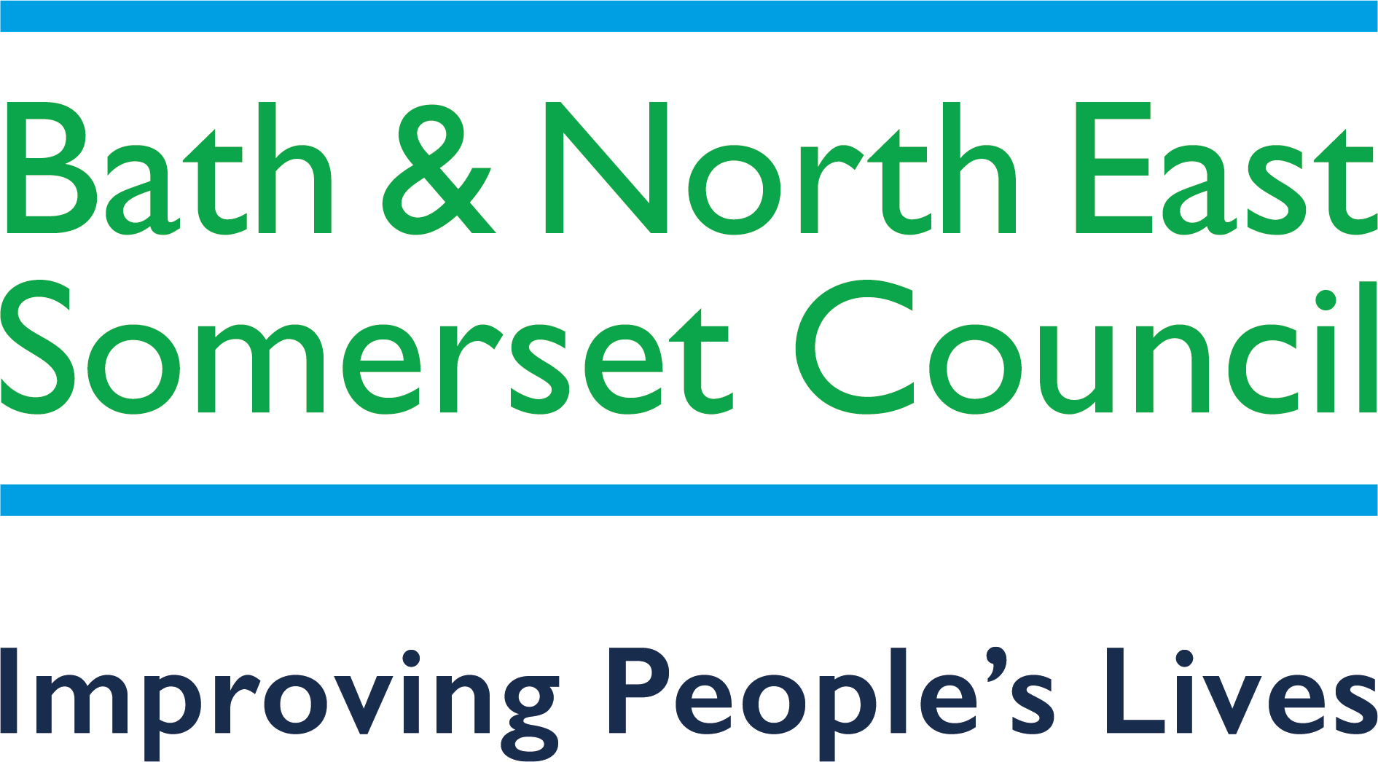
Local First Framework 2023-24
Information for Parents/Carers

Local First—what do we mean?

To achieve the Preparing for Adulthood life outcomes, we believe in enabling young people with special Educational Needs and/or a Disability (SEND) to gain their further education locally, whenever possible. Access to good quality local educational provision is considered beneficial for many young people preparing for adulthood, as it helps them to build independence and achieve their aspirations with a network of support in their local communities.

What do families need to do?
As part of Education Health and Care planning from year 9, the following steps may be useful in investigating local provision options as a first step, with contact details below:

- Approach your local College to discuss options;
- Consider a five day local Further Education bespoke package, to include respite and independent living support in ‘wrap-around’ support;
- A SEND Personal Budget can give full choice and control over tailoring support to need;
- Consider supported employment options;
- Referral to Local Authority Transitions Panel for consideration for Adult Social Services assessment.

Local Provisions

City of Bath College
Please visit Bath College website to find information on a number of different courses to meet different abilities and academic levels, ranging from pre-entry through Foundation and vocational programmes to HE. The courses include:
- Pathways for Adulthood (PfA) for pre-entry PMLD learners run at Wellow House, the SEND Centre on the Somer Valley Campus at Norton Radstock;
- Life for Independent Living Skills (LILS) is for entry level students needing to develop life skills.
There is the potential for these courses to be built into a 5-day package or, alternatively to be delivered in partnership with Adult Social Care.
There are also a number of work based programmes for SEND Learners including Partnership for Learning, Supported Routes to Employment (SuRE), Learning for Work and Traineeships. Please see the Bath College website and search ‘Foundation’ for further information.

City of Bristol College
City of Bristol College’s one year Sensory course at pre-entry level at the Ashley Down and South Bristol Skills Academy (SBSA) Centres is a three day course but this could be built into a five day package. City of Bristol College also offer a variety of Pathway and Entry Level 3 Vocational courses which enable learners with learning difficulties to progress into mainstream college, Supported Internships or help to gain independence skills. Courses are located across four sites in Bristol, more information on each course is City of Bristol College’s website, search for ‘Additional Learning Support’, or email learningsupport@cityofbristol.ac.uk.

There is also the Brislington Centre which is a residential training facility located near the SBSA site in Hengrove. The Transitions team would be happy to discuss entry requirements for this facility and application process. All queries need to be made through the college website using the link above.

Further information, support and advice

SENCO (Special Educational Needs Coordinator) based in all schools.
SEND Team is responsible for completing the Education, Health and Care plan, organising provision and administering the plan. The SEND Practitioner for the young person can advise on local provision options. The SEND team can be contacted via phoning 01225 394306 or by emailing special_educationalneeds@bathnes.gov.uk.
B&NES Budgets, Placements and Commissioning Officer can advise and signpost on local provision options, five day bespoke provision packages, and eligibility for SEND Personal Budgets where education funding can be linked to social care direct payments. They can be contacted by calling 01225 394306.
The Inclusion Service at Bath College can be contacted on 01225 328560.

Sendias Bathnes
SENDIAS offer confidential, impartial legally based information, advice and support to children and young people with SEND aged 0-25 and their parent carers regarding education, health and social care.
They can be contacted via Sendias Bathnes website or as follows:
- Call their advice line between 10.00 am – 3.00 pm Monday to Friday on 01225 394382
- Email: sendias@bathnes.gov.uk

Live Well B&NES
Find local and specialist information, signposting and guidance for young people aged 0-25 years with a special educational needs/disabilities, and their parent carers.
Visit the Live Well B&NES website to find out more.
B&NES We Work for Everyone Navigators
This regional project supports young people with disabilities into employment.
For a referral form/advice please contact: nikki_dimond@bathnes.gov.uk

B&NES Parent Carer Forum
B&NES Parent Carer Forum CIC is the recognised Parent Carer Forum for this area. The Forum provides peer support for parent carers of children and young people with SEND from 0-25 years old. The Forum acts as the strategic partner for parent carer participation and, through feedback and consultations, works to empower parent carers to fully participate in co-production to ensure the best outcomes for children and young people with SEND, and their families. More information can be found on the B&NES Parent Carer website.

Youth Connect South West

Working with young people aged 11-25 years to support, challenge and enable the learning of young people to realise their full potential. You can find out more by visiting the Youth Connect South West website or by calling 01225 396980.

Off The Record

Off The Record provide a range of free, confidential and independent services for children and young people that supports the development of their emotional health and well being. You can find out more by visiting the Off The Record website or by calling 01225 312481.

Bath and North East Somerset Community Health and Care Services (HCRG) Care Group

Providing health and social care support in B&NES, for more information please visit the HCRG website.

Preparing for Adulthood

You can find information about Preparing for Adulthood on Live Well B&NES website.

For specific advice around preparing for adulthood you can visit the Transition Information Network. They share tools and resources to support you or your young person to prepare for adulthood please visit the NDTi website for tools and resources.

This document can be made available in a range of languages, large print, Braille, on tape, electronic and accessible formats.

