Bath and North East Somerset Short Break Statement

April 2024

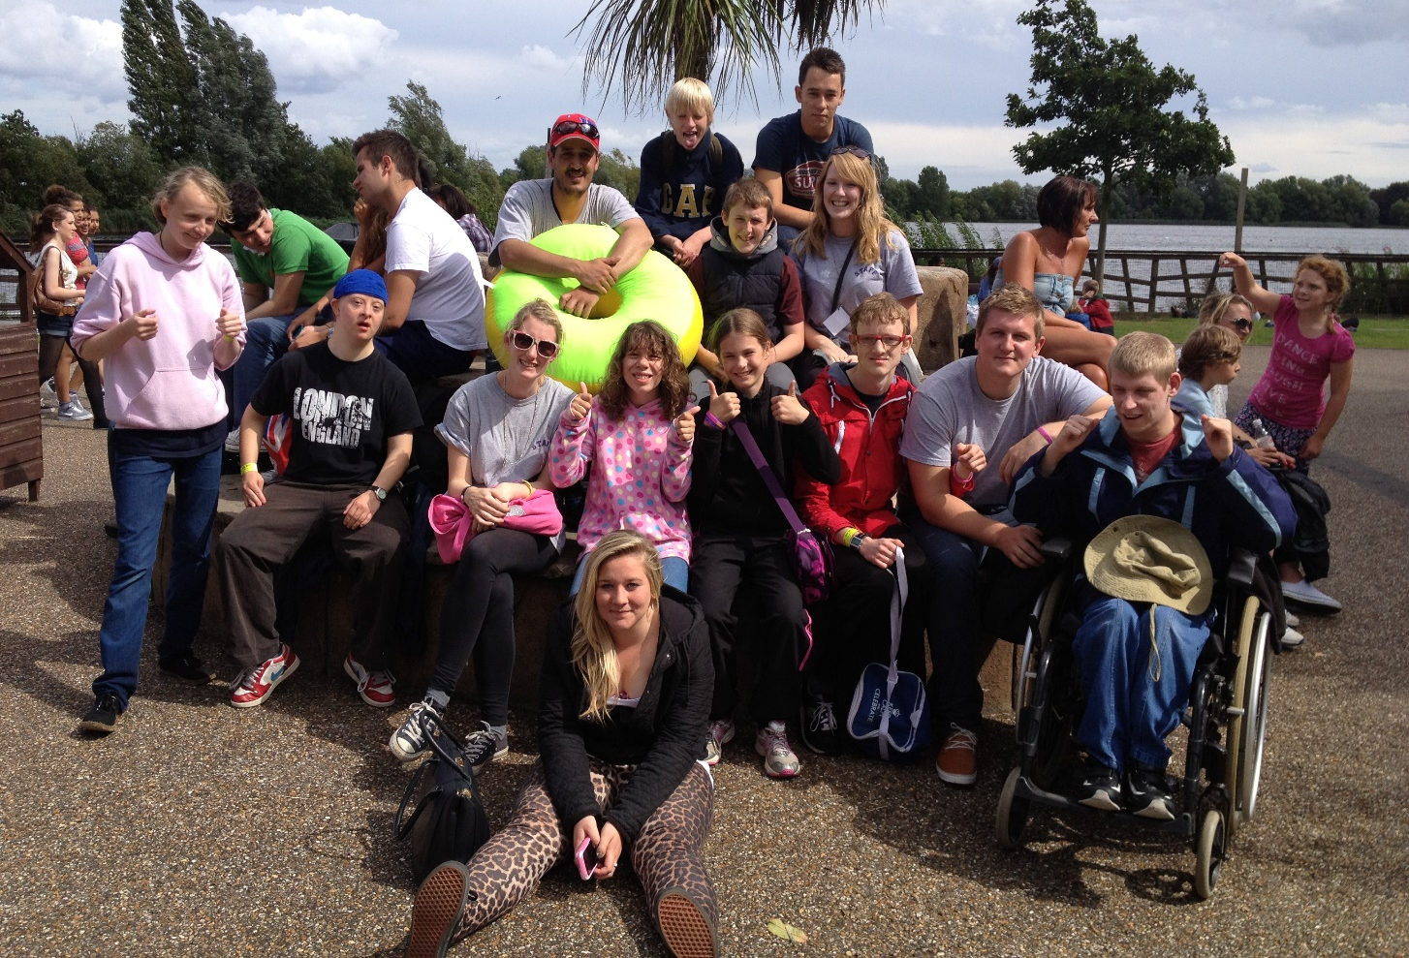

Contents Page

- Introduction
- The Law
- Our Aims
- Demographics
- What is a short break?
- Who is entitled to a Short Break?
- How to Access Short Breaks and Activities for Children and Young People with Special Educational Needs and/or Disability.

- Other Support Services
- Transitions into adulthood
- Principle for a good transition
- Feedback from families
- Appendix 1 – additional information
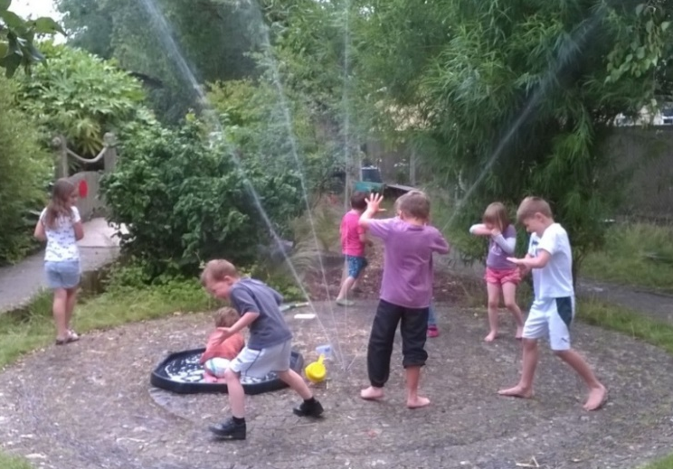
Introduction
This document provides information about the range of services available to families of children and young people with a disability or additional need living in Bath and North East Somerset area aged 0-21 years however the legislation refers to young people aged 0-25 years.
The short breaks that are commissioned by the Council; parent carer groups report that this has led to improved outcomes for disabled children, young people and their families and has also provided evidence for those planning and providing services. Examples of improved outcomes include young people forming friendships with peers in their community and being supported to develop independent skills.
The Law
There are legal duties that the Local authority have, which relate to short breaks, these can be found within:
- Children’s Act 1989 and Breaks for Carers of Disabled Children Regulations 2011
- Chronically Sick and Disabled Person’s act 1970
- Children act 2004
- Children and Families Act 2014
- Equality Act 2010
- NHS Act 2006 (as amended by the Health and Social Care Act 2012)
- Care Act 2014 (in relation to adult social care)
Our Aims
We want good quality services that offer positive experiences for children and young people with special educational needs and/ or disability, particularly where they are unable to easily access other opportunities in their local community,
We want our short breaks to provide children and young people with enjoyable experiences, that help them with their personal, social and educational development. At the same time, we want them to give parents and carers a valuable break, allowing them to rest, pursue other interests or spend time with other family members.
We know that each family’s needs are different and for this reason we want to offer a range of services which are suitable to meet the needs of all disabled children and young people.
We listen to children, young people and their families and use their feedback to change and develop services.
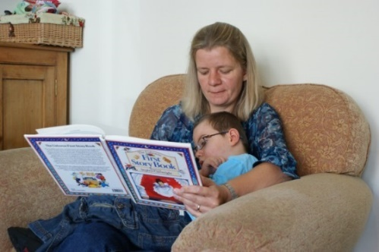 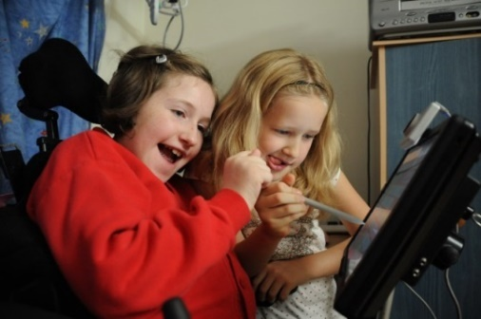Demographics
A range of data is available such as attendance sheets, performance levels and levels of satisfaction of services commissioned by the Council as well as demographic data and reach data. By collecting data in this way the Council can demonstrate value for money and set out clear outcomes when developing strategic plans and commissioning of short breaks.
Age Group | Number of children and young people
0 to 5 | 149
6 to 10 | 643
11 to 15 | 839
16 to 20 | 580
21 to 25 | 88
Total: | 2299
Gender | Number of children and young people
Male | 1524
Female | 770
Gender Fluid (Born Female) | 2
Non-Binary | 2
Transgender Female (Assigned Male at birth) | 1
Total: | 2299

Ethnicity (Top 5) | Percentage
White British | 81.99%
Any other White Background | 3.91%
White and Black Caribbean | 3.26%
Any other mixed background | 2.74%
White and Asian | 1.04%

Data Source: FACT Disability, EHCP, LCS Disabled Flag - April 2024
What is a short break?
A short break is when children and young people with Special educational Needs and/ or disability (SEND) participate in activities that they enjoy in their leisure time (outside school hours) for example playing sport, spending time with friends, joining a club to spending a few days away from home:-
- This allows children and young people to experience new relationships, environments and positive activities
- Provides a necessary and valuable opportunity for primary carers (usually but not always, mum or dad) to have a break from their caring responsibilities, and to recharge their batteries
- May include day, evening, overnight or weekend activities and could take place at home, at an approved carer’s home or in a community or residential setting
- May mean taking part in an activity with other disabled young people or being supported to take part in local activities open to everyone
- Can also mean supporting parents in their caring role so that the whole family can enjoy activities together
Who is entitled to a short break?

Children and young people are eligible for short breaks if they have a “physical or mental impairment, which has a substantial and long-term effect on their ability to carry out day-to-day activities.” (Source: The Equality Act 2010). This may include:-
- Physical or mental impairment
- Sensory impairment
- Autistic Spectrum Disorder
- Children who may have challenging behaviour as a result of their disability
    - Children who have complex healthcare needs and who may have palliative, life limiting or life-threatening conditions
    - Children/young people with a statement of Special Educational Needs or Educational Health and Care Plan (EHCP) where the plan has been issued in recognition of the child’s disability.
Other requirements include:-
- Child who is a resident in Bath and North East Somerset
- Is of the age range of the provision taking pace.
How to access Short Breaks and activities for Children and Young people with Special educational Needs and/or Disability (SEND)

Bath and North East Somerset believe that in order for services to be provided fairly and within an equality framework there must be consistency throughout all of Children's Services. Some services can be accessed by contacting the provider directly e.g. school holiday schemes whereas other services such as short-term overnight care will require an assessment. The level of support a child would need to access provision depends on the severity of the child's disability and the needs of the rest of the family. This support is categorised into four levels universal, targeted, specialist support and acute specialist support.
Many children will access a mixture of services, some specialised ones that are provided through an assessment and some that are accessed through universal and targeted activities, which have been commissioned from voluntary or independent sector groups.
Service Type | How to access these services | Examples
Universal | Families access these services directly. | Youth clubs,  Sports and leisure centre  After school clubs  Scouts, Brownies  Music Clubs  Holiday clubs  Saturday clubs
Targeted | Families can access some of these services directly. Access is not necessarily dependant on a formal assessment although each service may operate their own criteria. | Same as above with additional staff to support group activity.
Specialist | A formal assessment is required usually through the Disabled children’s Team (DCT). Eligibility criteria are used to determine the level of service required for each family. | Speech and Language Therapy  Overnight provision  Specialist support teams  Physiotherapy treatments  Direct Payments
Acute Specialist support | A formal assessment is required usually through a specialist team i.e. continuing care team. Eligibility criteria are used to determine the level of service required for each family. | Personal Budgets  Direct Payments  Hospice Care

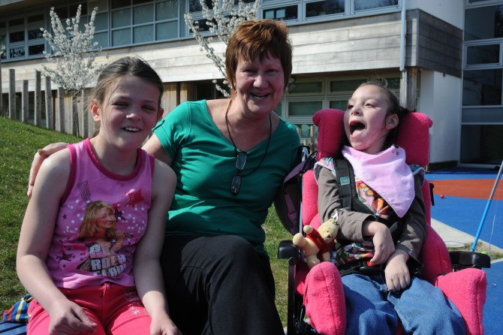
Other Support Services
Sendias Bathnes (SB) provides impartial, confidential information, advice and support for children and young people with SEND aged 0-25 and their families in Bath and North East Somerset in matters relating to education, health and social care. SB can signpost families to activities and other relevant organisations in the area.

To talk to one of the SB team please call Sendias Bathnes on 01225 394382, email sendias@bathnes.gov.uk or use the get in touch button on our website https://sendiasbathnes.org.uk/ or send a text message to 07530 263401.

The Rainbow Resource is a searchable database providing information about a range of services, organisations and activities in the local area for families of children and young people with SEND. Families can apply for a Rainbow Resource Card which gives the card holder concessions to some activities, some organisations and events. Full details, including the online application form, can be found on the Council’s Rainbow Resource Scheme pages.

The Council commissions’ family support services through the Southside Project. They work directly with families to support them with many complex issues including issues around disability. You can find more information about Southside on their website: Southside website.
The SEND advocacy service at Off the Record currently provides an advocacy service for disabled children and young people and also provide an independent advocacy service for young people with SEND for their year 11 reviews. To ensure you are directed to the right service for the support you require please contact office@offtherecord-banes.co.uk
Off the Record also offer other advocacy services to disabled children and young people and you can contact them directly to find out more. email office@offtherecord-banes.co.uk
Parent carers and, where appropriate, young people are fully involved in all aspects of short breaks development. They are involved in making key decisions about short break provision. As a result, the development of the range of short break services has grown reflecting the needs of families in the area. If you would like to have your say and get involved, please contact B&NES Parent Carer Forum (BPCF). They can be contacted at info@banespcf.co.uk as well as via their Facebook page https://www.facebook.com/BNES-Parent-Carer-Forum-115947117762989 and www.banesparentcarerforum.co.uk
The Diamond Travel card offers free off-peak bus travel for older people and those with disabilities who live in Bath & North East Somerset. To access more information about the Diamond Travel card please follow this link: Diamond Travel Card information
There are three types of community transport schemes operating in most parts of Bath & North East Somerset:
- Dial-a-ride
- Mini Bus Schemes
- Voluntary Car Schemes
To find out more about the community transport scheme, please follow the link here: Community Transport
Organisations that offer short breaks to disabled children may be able to offer a solution to particular issues around transportation.
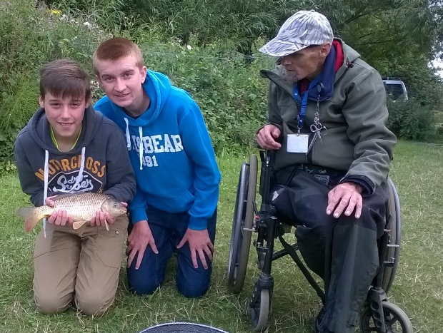

Transitions into Adulthood

Transition involves the many changes that occur as a young person moves through their teenage years and into adult life. These changes may include the transition from school to college, college to adult life and include thinking about and planning for employment, housing, good health and accessing things in the community. Schools, colleges health and social care should work together to support young people with special educational needs and disabilities to prepare for adult life.
Preparing for Adulthood is a key element of the Special Educational Needs and Disabilities (SEND) reforms that aims to improve young people’s achievement of the four key outcomes:
- Employment and further education
- Living independently
- The best health possible
- Having friends and relationships and being able to participate in the local community
A number of different agencies have responsibility for providing services to young people with additional needs and/or who are disabled and have special educational needs. Collaboration and coordination between agencies is essential for young people who may need to have their needs individually assessed. This ensures that the transition is smoother, and all partners are aware of their roles and responsibilities.

Professionals working with young people known to B&NES Children’s Services will start to discuss transitioning beyond Children’s Services from at least Year 9. If during these discussions, professional thinks a young person or carer is likely to have needs for care and support when a young person turns 18, or when their young person turns 18, they should ask for consent to make a referral to Transitions Panel. If a young person has an EHC plan or a Social Care plan, the timing of a Transitions Assessment must coincide with any reviews of those plans. The table below explains the other assessments or reviews of plans that your Transition Assessment may be carried out at the same time as.

EHC plan Annual Reviews | If a young person has an EHC plan, an Annual Review meeting is held once a year. From Year 9 onwards a Transitions Assessment can be carried out during any of our Annual Reviews.
Annual School/education setting meetings | If you don’t have an EHC plan, a class teacher, SENDCO or other education professional, will meet with the young person or carer at least once a year to talk about progress. When a young person is 14 or older these meetings should also look at what the young person would like to do after you leave education. Transitions Assessment can be carried out as part of any of these meetings if it is appropriate.
Care Plan Reviews | If the young person has a Care Plan because they are a Child in Care or have a Child Protection Plan, it will be reviewed every 6 months. If the young person is known to the Children in Care Team and the plan is still in place when they turn 15 ¾, the Transitions Assessment will be carried out as part of their Care Plan review. If the young person is known to the Disabled Children’s Team, the Transition Assessment should be carried out earlier, before the young person reaches the end of year 10.
Health Care Plan Review | If you are receiving a specialist Health service, like CAMHS, you will have a Health Care plan in place. For however long this plan is in place, it will be reviewed annually. Your Transitions Review will take place during one of the reviews of your Health Care plan, after year 9.

Principles for a Good Transition

Our key principles for supporting young people to transition beyond Children’s Services are:

Young people come first | - Transition to adult services will happen when it is the best time for the young person, not the best time for services.  - They should be person centred  - If a young people can, they should make decisions for themselves.  - Young people, and their families are fully involved in transitions
Services support to navigate the system | - Young people who are likely to have a complex transition should have a named key worker to support them  - There is good transition planning for young people
Information is key | - Everyone should be able to access information about the different services available after they leave Children’s Services.  - There should be multiple opportunities for young people and families to explore what happens when their young person leaves education.  - There are range of services for young people and their families to choose from.

Feedback from families
ASD youth club is a great release for my child. he has learnt to make friends and have fun with them in a safe environment
My child attends the BAPP play scheme during school holidays. It's amazing for her, it helps her anxiety and the activities are stimulating and fun for her and fulfil her sensory needs
As a parent it was amazing to have a service that understand her medical as well as her SEND needs.

More activities needed on North side of Bath - Weston, Newbridge, Lansdown.
I'm not really aware of any activities in the area.

He can try different activities and it gives him a routine during the school holidays which he really needs. Everyone who looks after him are caring and knowledgeable about his needs. I can leave him there and know he is well looked after.

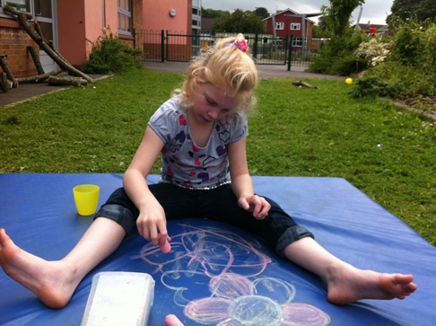
More useful trips to fun things that children actually want to do like the cinema or bowling
For more information about this statement, contact: Armi Jones, Specialist Commissioning Officer, Bath and North East Somerset Council, Keynsham Civic Centre, Market Walk, Keynsham, BS31 1FS 01225 395026, armi_jones@bathnes.gov.uk
Appendix 1
Additional information

Definitions
The Children Act 1989 sets out legal framework for how services for children and their families are provided.
This policy and procedure relate to children and their families who are in need. As such the definition is taken from the Childrens Act 1989. Section 17(1) states that “it shall be the general duty of every local authority:
To safeguard and promote the welfare of children within their area who are in need; and so far as is consistent with that duty, to promote the upbringing of such children by their families by providing a range and level of services appropriate to those children's needs”.

Child in Need definition
The Childrens Act 1989 section 17(10) states that a child shall be taken as in need if: A 'child in need' may be:
- disabled
- unlikely to have, or have the opportunity to have, a reasonable standard of health or development without services from the local authority; or
- unlikely to progress in terms of health or development; or
- unlikely to progress in terms of health or development; without services from the local authority
Disability Definition
The Childrens Act 1989 section 17(11) states that a child is disabled if:
“he is blind, deaf or dumb or suffers from mental disorder of any kind or is substantially and permanently handicapped by illness, injury or congenital deformity or such other disability as may be prescribed”
'Development' means physical, intellectual, emotional, social or behavioural development; and 'health' means physical or mental health.
The Equality Act 2010 defines disability as:
“A physical or mental impairment which has a substantial and long term adverse effect on a person's ability to carry out normal day to day activities”
Those covered by this definition would include anyone who permanently unable to use a limb, see or hear. Children or young people with a learning disability or with a long lasting clinically well – recognised mental illness.
The meaning of long term is lasting, or being likely to last, at least 12 months.
Special Educational Needs and Disability (SEND)
The Children and Families Act 2014 transformed the way support is provided for children and young people with Special Educational Needs and/or disabilities up to the age of 25. Support focuses on enabling children, young people and their families to achieve their long term aspirations
All Local Authorities are required to publish a Local Offer of the support and services we expect to be available for children and young people aged 0 – 25, from children and young people with a low level of special educational need or disability, through to the most complex needs. The Local Offer is a continuing piece of work and will be reviewed and updated regularly. It can be found here: Special Educational Need or Disability (SEND) Rainbow Resource | Live Well in Bath & North East Somerset (bathnes.gov.uk)
SENCo (Special Educational Needs Co-Ordinator)
The SENCo coordinates the provision made for individual children with a Special Educational Need (SEN) working closely with staff, parents and carers, and other agencies. The SENCo also provides related professional guidance to colleagues with the aim of securing high quality teaching for children with SEN.
Direct Payments
If you qualify for help through an assessment you can choose to receive a 'direct payment' to buy services you need to meet your needs as a family. On the whole this is instead of receiving services direct from the council.

Contacts

- Disabled Children's Team (DCT) 01225 396967
- Southside Project Tel: 01225 331243
- SENDIAS Tel: 01225 394382, email sendias@bathnes.gov.uk
- Off the Record – 01225312481, Text 07753891745, email office@offtherecord-banes.co.uk
- Rainbow Resource - www.rainbowresource.org.uk.
- B&NES Parent Carer Forum website: www.banesparentcarerforum.co.uk

