Stories to support Transitions

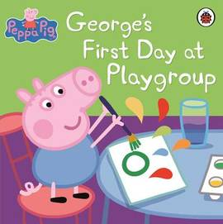

When Peppa's brother George joins her at playgroup, she doesn't want him to be there! But Peppa's friends like George and decide they want little brothers, too. Will Peppa change her mind? This reassuring tale will help children understand what a first day at preschool, nursery, playgroup or school might be like. Featuring the much-loved Peppa Pig characters, this is guaranteed to comfort and delight little ones.

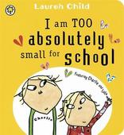

Bestselling author Lauren Child presents a beautiful Charlie and Lola classic, but this time, little Lola is starting school! She's very nervous though, and Charlie must try to persuade her that her fears, including about the dreaded 'schooliform', are completely unfounded. This gentle and helpful story is perfect for children who are worried about going to school for the first time.

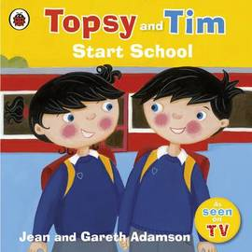

Follow fun-loving twins Topsy and Tim as they start their first day at school and experience all sorts of new things, from learning where to put their coats to exploring the classroom and making new friends! Kids will love the bright, contemporary artwork and recognisable, charismatic characters.

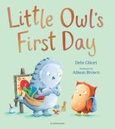

This lovely picture book sees Little Owl take on his first day at school. Initially, he's very nervous and decides he'd rather stay at home with Mummy and Baby Owl than go to school. But, when he has his dreaded first day he is surprised to learn just how fun school can be. He makes friends and builds sandcastles and can't believe how much he's enjoyed himself! This lovely book, illustrated by There's a Boy Just Like Me illustrator Alison Brown, is the perfect bedtime read for those who are nervous about starting nursery or primary school.

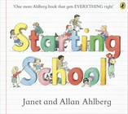

This picture book from Janet and Allan Ahlberg provides a funny and heart-warming take on starting school to chase the nerves away. The book focuses on a group of children going through their first term at school so young readers will know what to expect. If you're looking for a reassuring book that will remove the mystery of the first day for your child, this is an excellent choice.

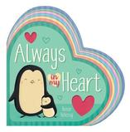

This lovely book shows young children how to deal with separation anxiety which some children just starting nursery or school may struggle with. If your child needs a reassuring reminder that even when they are away from you, they don't need to feel stressed and unhappy then this is the book for them.