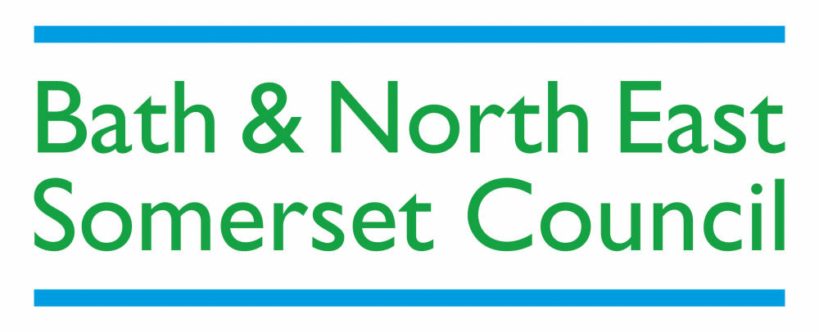

Disability Access Fund (DAF) – Request Form

Section 1) Child and Family details

Child’s Name |  | DOB
Gender |  | Ethnicity
Parents / Carers Names |  | Parents / Carers Address
Contact Number |  | Postcode

Section 2) Early Years Setting Details

Early Years Provider Name

Early Years Provider Email Address |  |  | Contact Name
I confirm that evidence of Disability Living Allowance (DLA) has been seen and I have enclosed proof of this for the above named child.
Please note payment will not be made without proof of DLA.
EY Provider Name |  | EY Provider Signature |  | Date

Section 3) Details on how the funding will be used

What are you going to do differently or more of?
How will you know it has made a difference?

Section 4) Parental consent and additional information

It is important to note that Disability Access Funding will not be refundable and once payment has been made that decision is final. Even if your child moves to a different Early Years Provider the Disability Access Funding will not be available until 12 months after this payment. It is also important to note that this fund will only be issued to an Early Years Provider once a signed headcount form has been received which clearly shows the child for which the fund is being claimed.

I confirm that Disability Access Funding (DAF) of £975.00 should be paid to the above Early Years Provider.
I understand that the Council will share this information with other teams within People & Communities in order to provide a comprehensive service to you and your family. The Council will not share information with any other third party without your consent or as required by law.
Parent / Carer Name | Parent / Carer Signature | Date

Please return this form via GlobalScape / NEXTCloud or to the following address:

Early Years Special Educational Needs and Disability Inclusion Panel (SENDIP)
Bath and North East Somerset Council
Lewis House, Manvers Street, Bath
BA1 1JG

Email – SENDIP@bathnes.gov.uk

