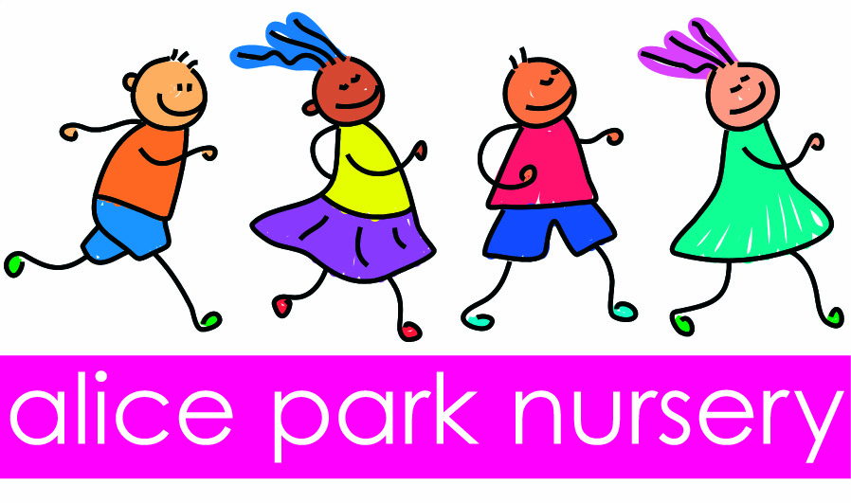
Alice Park Nursery Ofsted Number EY373060
At Alice Park Nursery we know that every child is unique. We are committed to providing each child with the best possible outcomes in learning and development.
Our nursery is set in the grounds of Alice Park in one of the park keepers cottages. The property is on two floors with all age groups using the rooms upstairs as well as down.
At Alice Park Nursery we do ongoing observational assessments of all children in our care. These are linked to the development matters ages and stages of development, which can help us identify individual needs of the children. These observations will be discussed with the setting SENCO (Barbara Rawlings) and setting Manager.
We operate a Key persons system, with each child having a Key Person. Their role is to develop trusting, sensitive relationships with parents and children to enable respectful sharing of information. If you have any concerns about your child’s development you can ask for time to discuss this in private with them. If your child’s key person has identified a possible individual need they will discuss the matter with you in private and plan together to support your child’s learning and development.
Barbara Rawlings, our trained SENCO can offer advice and support to the key person. The SENCO will liaise with other professionals to seek advice and support in identifying individual needs if necessary. Support and advice from the Area SENCO and the Early Years Advisory Teacher can be sought with parents’ permission.
Reports from health care professionals such as health visitors, speech and language therapists identify children’s individual needs. The setting welcomes parents and professionals sharing these reports with them in order to plan appropriately to meet individual needs
When starting nursery all children are offered settling sessions to help them settle into nursery life. As each child is unique we tailor the sessions to the needs of the child and parents.
When a child is moving on to school or to a new setting, the child’s new key person and SENCO are invited to observe the child and discuss the child’s strengths and needs. Photo books can be created of the new setting /school that the child can share with parents / key person on a regular basis before the move. The use of role play with school uniform and books is a good way to help a child become familiar with new routines. If the school is involved in the “Get Set project” we would enrol the child on to this.
As we have said every child is unique and we would invite you to come and discuss your child’s needs to see if we can provide the right environment for them to grow and develop to their full potential.

